# Chapter Two | Overall Description & Requirement

## **2.1 Product Perspective**

## **2.2 User Characteristics**

## **2.3 Features**

**There are three types of users:**

- Administrator

- Lecturer

- Student

**Feature#1 User registration**

**Description:** This feature supports registration of users for using the system.

**Users:** Lecturer, Student, Administrator

**Details:**

**1-1 Lecturer/Student:** Lecturer/Student can request to register in the system..

**1-2 Administrator:** Administrator can approve registration requests from Lecturers and Students.

**Feature#2 Login to the system**

**Description:** This feature supports access to the system.

**Users:** Lecturer, Student, Administrator

**Details:**

**2-1 Lecturer/Student/Administrator:** User can login to the system.

**2-2 Lecturer/Student/Administrator:** User can logout from the system.

**Feature#3 Course management**

**Description:** This feature supports managing semesters to respond academic year that change over time by Administrator. Lecturer manages his/her courses offered in each semester. Student accesses course information registered.

**Users:** Administrator, Lecturer, Student

**Details:**

**3-1 Administrator:** Administrator can create, edit, and delete semesters.

**3-2 Administrator:** Administrator can create, edit, and delete a course in the semester.

**3-3 Administrator:** Administrator can register a list of students to a course.

**3-4 Lecturer:** Lecturer can access information of his/her course.

**3-5 Student:** Student can see access information of his/her course registered.

**Feature#4 Assignment and Quiz management**

**Description:** This feature supports assignment and quiz management by Lecturer. This feature can process Student’s answer to each question of an assignment or quiz and compute the score. Moreover, this feature supports preventing Student from copying assignments or quizzes which are multiple choices and true/ false questions. The system can randomize the order of questions.

**Users:** Lecturer

**Details:**

**4-1 Lecturer:** Lecturer can assign, edit and delete assignments or quizzes which are multiple choices, true/false questions, short answers.

**4-2 Lecturer:** Lecturer can limit access to the assignment or quiz of authority.

**4-3 Lecturer**: Lecturer can review overall student’s answer in each choice of assignment or quiz in chart format.

**4-4 Lecturer:** Lecturer can post an assignment or quizzes.

**4-5 Lecturer:** Lecturer can check whether the assignments are submitted in time.

**4-6 Lecturer:** Lecturer can randomize the order of questions in an assignment or a quiz.

**Feature#5 Taking assignments and quizzes**

**Description:** This feature supports taking assignments and quizzes by student.

**Users:** Student

**Details:**

**5-1 Student:** Student can take assignments or quizzes which are multiple choices, true/false questions, short answers

## **2.4 Functional & User Requirement**

### **URS2-1. Lecturer can register to the system**

**SRS2-1-1:** The system shall redirect to Lecturer registration page on the mobile application.

**SRS2-1-2:** The system shall redirect to Lecture main page on the mobile application.

**SRS2-1-3:** The system shall provide Lecturer registration interface on the mobile application, including lecturer ID, lecturer username, lecturer password, lecturer name, lecturer faculty, lecturer department, lecturer email, and lecturer tel for Lecturer register to the system.

**SRS2-1-4:** The system shall store the Lecturer personal information into the system after Lecturer submitted his/her register information from Lecturer registration interface on the mobile application.

**SRS.2-1-5:** The system shall display “Registration Successful” message when Lecturer registered the Lecturer account in Lecturer registration interface on the mobile application.

**SRS.2-1-6:** The system shall validate the format of the Lecturer personal information after the Lecturer submitted his/her information from Lecturer registration interface on the mobile application.

**SRS.2-1-7:** The system shall display “The Lecturer ID must be the number only” when the lecturer ID format is wrong.

**SRS.2-1-8:** The system shall display “The Lecturer’s username must be only 4-16 alphabet characters” when the lecturer username format is wrong.

**SRS.2-1-9:** The system shall display “The Lecturer’s password must be only 4-16 characters” when the lecturer password format is wrong.

**SRS.2-1-10**: The system shall display “The Lecturer’s name must be the combination of alphabet and space only” when the lecturer name format is wrong.

**SRS.2-1-11:** The system shall display “The Lecturer’s tel must be number only” when the lecturer tel format is wrong.

**SRS.2-1-12:** The system shall validate the duplication of the lecturer username after Lecturer submitted his/her information from Lecturer registration interface on the mobile application.

**SRS.2-1-13:** The system shall display “Existing Lecturer’s username, please using different Lecturer’s username” when the lecturer username duplicates exist lecturer username.

### URS2-2. Student can register to the system

**SRS2-2-1:** The system shall redirect to Student registration page on the mobile application.

**SRS2-2-2:** The system shall redirect to Student main page on the mobile application.

**SRS2-2-3:**The system shall provide Student registration interface on the mobile application, including student ID, student username, student password, student name, student address, student faculty, student department, student email, and student tel for Student register to the system.

**SRS2-2-4:**The system shall store the Student personal information into the system after Student submitted his/her register information from Student registration interface on the mobile application.

**SRS2-2-5:**The system shall display “Registration Successful” message when Student registered the Student account in Student registration interface on the mobile application.

**SRS2-2-6:**The system shall validate the format of the Student information after the Student submitted his/her information from Student registration interface on the mobile application.

**SRS2-2-7:** The system shall display “The Student ID must be the number only” when the student ID format is wrong.

**SRS2-2-8:**The system shall display “The Student’s username must be only 4-16 alphabet characters” when the student username format is wrong.

**SRS2-2-9:**The system shall display “The Student’s password must be only 4-16 characters” when the student password format is wrong.

**SRS2-2-10:**The system shall display “The Student’s name must be the combination of alphabet and space only” when the student name format is wrong.

**SRS2-2-11:**The system shall display “The Student’s tel must be number only” when the student tel format is wrong.

**SRS2-2-13:**The system shall validate the duplication of the student username after Student submitted his/her information from Student registration interface on the mobile application.

**SRS2-2-14:**The system shall display “Existing Student’s username, please using different Student’s username” when the student username duplicates exist student username.

### **URS2-3. Lecturer can edit his/her personal information.**

**SRS2-1-2:** The system shall redirect to Lecture main page on the mobile application.

**SRS2-3-1:** The system shall redirect to Lecturer personal information interface on the mobile application.

**SRS2-3-2:** The system shall provide Lecturer personal information interface on the mobile application, including lecturer password, lecturer name, lecturer faculty, lecturer department, lecturer email, and lecturer tel for Lecturer edits his/her personal information into the system.

**SRS2-3-3:** The system shall update Lecturer personal information into the system after Lecturer submits to edit his/her personal information from Lecturer personal information interface on the mobile application.

**SRS2-3-4:** The system shall display “Editing Information Successful” message when Lecturer edited the Lecturer personal information in Lecturer personal information interface on the mobile application.

**SRS2-3-5:** The system shall validate the format of the Lecture personal information after Lecturer submitted his/her personal information from Lecturer personal information interface on the mobile application.

**SRS2-3-6:** The system shall display “The Lecturer’s password must be only 4-16 characters” when the lecturer password format is wrong.

**SRS2-3-7:** The system shall display “The Lecturer’s name must be the combination of alphabet and space only” when the lecturer name format is wrong.

**SRS2-3-8:** The system shall display “The Lecturer’s tel must be number only” when the lecturer tel format is wrong.

**SRS2-3-9:** The system shall display “The Lecturer’s email must be the character and only one @ symbol” when the lecturer email format is wrong.

**SRS2-3-10:** The system shall validate the similarity of password and confirm password after Lecturer submitted his/her personal information from Lecturer personal information interface in the mobile application.

**SRS2-3-11:** The system shall display “Password and confirm password is not matched” when password and confirm password is not matched.

### **URS2-4. Student can edit his/her personal information.**

**SRS2-2-2:** The system shall redirect to Student main page on the mobile application.

**SRS2-4-1:** The system shall redirect to Student personal information interface on the mobile application.

**SRS2-4-2:** The system shall provide Student personal information interface on the mobile application, including student password, student name, student faculty, student department, student address, student email, and student tel for Student edits his/her personal information into the system.

**SRS2-4-3:** The system shall update Student personal information into the system after Student submits to edit his/her personal information from Student personal information interface on the mobile application.

**SRS2-4-4:** The system shall display “Editing Information Successful” message when Student edited the Student personal information in Student personal information interface on the mobile application.

**SRS2-4-5:** The system shall validate the format of the Student personal information after Student submitted his/her personal information from Student personal information interface on the mobile application.

**SRS2-4-6:** The system shall display “The Student’s password must be only 4-16 characters” when the student password format is wrong.

**SRS2-4-7:** The system shall display “The Student’s name must be the combination of alphabet and space only” when the student name format is wrong.

**SRS2-4-8:** The system shall display “The Student’s tel must be number only” when the student tel format is wrong.

**SRS2-4-9:** The system shall validate the similarity of password and confirm password after Student submitted his/her personal information from Student personal information interface in the mobile application.

**SRS2-4-10:** The system shall display “Password and confirm password is not matched” when password and confirm password is not matched.

### **URS2-5. Lecturer/Student can login to the system.**

**SRS2-1-2:** The system shall redirect to Lecture main page on the mobile application.

**SRS2-2-2:** The system shall redirect to Student main page on the mobile application.

**SRS2-5-1:** The system shall provide Login interface on the mobile application, including username and password for Lecturer/Student login his/her account into the system.

**SRS2-5-2:** The system shall fetch login information of Lecturer/Student from the system to validate the correctness of login information in Login interface on the mobile application.

**SRS2-5-3:** The system shall display “Invalid Username and/or Password” when username and password are wrong to Lecturer/Student.

### **URS2-6. Lecturer/Student can log out from the system.**

**SRS2-1-2:** The system shall redirect to Lecture main page on the mobile application.

**SRS2-2-2:** The system shall redirect to Student main page on the mobile application.

**SRS2-5-1:** The system shall redirect to Login page on the mobile application.

**SRS2-6-1:** The system shall provide Log out form in Lecture main page on the mobile application.

**SRS2-6-2:** The system shall provide Log out form in Student main page on the mobile application.

### **URS2-7. Lecturer can view courses information.**

**SRS2-1-2:** The system shall redirect to Lecture main page on the mobile application.

**SRS2-7-1:** The system shall redirect to Course management page on the mobile application.

**SRS2-7-2:** The system shall provide all courses name in Course management page on the mobile application which were taught by finding from lecturer ID.

**SRS2-7-3:** The system shall redirect to Course main page on the mobile application.

**SRS2-7-4:** The system shall redirect to Course information page interface on the mobile application, including course name, course credit, course description, lecturer name, a list of students in the course.

**SRS2-7-5:** The system shall fetch the course information from the system to display into Course information page on the mobile application.

### **URS2-8. Student can view courses information.**

**SRS2-2-2:** The system shall redirect to Student main page on the mobile application.

**SRS2-7-4:** The system shall redirects to Course information page interface on the mobile application, including course name, course credit, course description, lecturer name, a list of students in the course.

**SRS2-7-5:** The system shall fetch the course information from the system to display into Course information page on the mobile application.

**SRS2-8-1:** The system shall redirect to Overall course page on the mobile application.

**SRS2-8-2:** The system shall provide all courses name in Overall course page on the mobile application which were studied by finding from student ID.

**SRS2-8-3:** The system shall redirects to Course main page on the mobile application.

### **URS2-9. Lecturer can assign assignments or quizzes which are multiple choices question, true/false question, and short answers.**

**SRS2-1-2:** The system shall redirect to Lecture main page on the mobile application.

**SRS2-7-1:** The system shall redirect to Course management page on the mobile application.

**SRS2-7-2:** The system shall provide all courses name in Course management page on the mobile application which were taught by finding from lecturer ID.

**SRS2-7-3:** The system shall redirect to Course main page on the mobile application.

**SRS2-9-1:** The system shall redirect to Overall testing page on the mobile application.

**SRS2-9-2:** The system shall redirect to Addition testing page on the mobile application.

**SRS2-9-3:** The system shall provide Addition testing page interface on the mobile application, including testing name, a type of testing, an amount of questions, student name, randomize order of the question status, and posting status for Lecturer adds an assignment or quiz into the system.

**SRS2-9-4:** The system shall validate testing information from Lecturer

**SRS2-9-5:** The system shall redirects to Assigning assignment and quiz page on the mobile application.

**SRS2-9-6:** The system shall provide Assign assignment and quiz page interface on the mobile application, including a type of question, question description, choice description, and an answer for Lecturer assigns assignments or quizzes into the system.

**SRS2-9-7:** The system shall validate assignment or quiz information from Lecturer.

**SRS2-9-8:** The system shall store the testing information from Lecturer into the system.

**SRS2-9-9:** The system shall store assignment or quiz information from Lecturer into the system.

**SRS2-9-10:** The system shall display “Amount of questions must be number only” message when the amount of questions format is wrong.

**SRS2-9-11:** The system shall display “Answer must be a, b, c, and d only” message when the multiple choices answer format is wrong.

**SRS2-9-12:** The system shall display “Answer must be a and b only” message when the true/false answer format is wrong.

**SRS2-9-13:** The system shall display “Creating Assignment Successful” message when Lecturer assign an assignment is successful.

**SRS2-9-14:** The system shall display “Creating Quiz Successful” message when Lecturer assign a quiz is successful.

**SRS2-9-15:** The system shall redirect to confirm creating testing page.

### **URS2-10. Lecturer can edit assignments or quizzes information which are multiple choices question, true/false question, and short answers.**

**SRS2-1-2:** The system shall redirect to Lecture main page on the mobile application.

**SRS2-7-1:** The system shall redirect to Course management page on the mobile application.

**SRS2-7-2:** The system shall provide all courses name in Course management page on the mobile application which were taught by finding from lecturer ID.

**SRS2-7-3:** The system shall redirect to Course main page on the mobile application.

**SRS2-9-1:** The system shall redirect to Overall testing page on the mobile application.

**SRS2-9-4:** The system shall validate testing information from Lecturer

**SRS2-9-7:** The system shall validate assignment or quiz information from Lecturer.

**SRS2-9-10:** The system shall display “Amount of questions must be number only” message when the amount of questions format is wrong.

**SRS2-9-11:** The system shall display “Answer must be a, b, c, and d only” message when the multiple choices answer format is wrong.

**SRS2-9-12:** The system shall display “Answer must be a and b only” message when the true/false answer format is wrong.

**SRS2-10-1:** The system shall redirect to Edition testing page on the mobile application.

**SRS2-10-2:** The system shall redirect to Edition assignment and quiz page on the mobile application.

**SRS2-10-3:** The system shall fetch the testing information from the system to display on Edition testing page on the mobile application.

**SRS2-10-4:** The system shall fetch the assignment or quiz information from the system to display on Edition assignment and quiz page on the mobile application.

**SRS2-10-5:** The system shall provide Edition testing page interface on the mobile application, including testing name, a type of testing, an amount of questions, student name, randomize order of the question status, and posting status for Lecturer adds an assignment or quiz into the system.

**SRS2-10-6:** The system shall provide Edition assignment and quiz page interface on the mobile application, including a type of question, question description, choice description, and an answer for Lecturer assigns assignments or quizzes into the system.

**SRS2-10-7:** The system shall update the testing information from Lecturer into the system.

**SRS2-10-8:** The system shall update assignment or quiz information from Lecturer into the system.

**SRS2-10-9:** The system shall display “Editing Assignment Successful” message when Lecturer edits an assignment is successful.

**SRS2-10-10:** The system shall display “Editing Quiz Successful” message when Lecturer edits a quiz is successful.

**SRS2-10-11:** The system shall redirect to confirm edition testing page.

### **URS2-11. Lecturer can delete assignments or quizzes which are multiple choices question, true/false question, and short answers.**

**SRS2-1-2:** The system shall redirect to Lecture main page on the mobile application.

**SRS2-7-1:** The system shall redirect to Course management page on the mobile application.

**SRS2-7-2:** The system shall provide all courses name in Course management page on the mobile application which were taught by finding from lecturer ID.

**SRS2-7-3:** The system shall redirects to Course main page on the mobile application.

**SRS2-9-1:** The system shall redirects to Overall testing page on the mobile application.

**SRS2-11-1:** The system shall deletes the testing information from the system.

**SRS2-11-2:** The system shall deletes assignment or quiz information from the system.

**SRS2-11-3:** The system shall display “Deleting Assignment Successful” message when Lecturer deletes an assignment is successful.

**SRS2-11-4:** The system shall display “Deleting Quiz Successful” message when Lecturer deletes a quiz is successful.

### **URS2-12. Lecturer can review overall student’s answer in each choice of assignment or quiz in chart format.**

**SRS2-1-2:** The system shall redirect to Lecture main page on the mobile application.

**SRS2-7-1:** The system shall redirect to Course management page on the mobile application.

**SRS2-7-2:** The system shall provide all courses name in Course management page on the mobile application which were taught by finding from lecturer ID.

**SRS2-7-3:** The system shall redirects to Course main page on the mobile application.

**SRS2-9-1:** The system shall redirects to Overall testing page on the mobile application.

**SRS2-12-1:** The system shall redirect to Chart format of student’s answer page on the mobile application.

**SRS2-12-2:** The system shall fetch the assignment or quiz information from the system.

**SRS2-12-3:** The system shall display overall student’s answer in each choice of assignment or quiz in chart format into Chart format of student’s answer page on the mobile application.

### **URS2-13. Lecturer can check whether the assignments are submitted in time.**

**SRS2-1-2:** The system shall redirect to Lecture main page on the mobile application.

**SRS2-7-1:** The system shall redirect to Course management page on the mobile application.

**SRS2-7-2:** The system shall provide all courses name in Course management page on the mobile application which were taught by finding from lecturer ID.

**SRS2-7-3:** The system shall redirects to Course main page on the mobile application.

**SRS2-9-1:** The system shall redirects to Overall testing page on the mobile application.

**SRS2-13-1:** The system shall redirect to testing submission page on the mobile application.

**SRS2-13-2:** The system shall fetch the testing submission information from the system.

**SRS2-13-3:** The system shall display testing submission information into testing submission page on the mobile application which consist student name, student ID.

### **URS2-14. Student can take assignments or quizzes which are multiple choices, true/false questions, short answers.**

**SRS2-2-2:** The system shall redirect to Student main page on the mobile application.

**SRS2-8-1:** The system shall redirect to Overall course page on the mobile application.

**SRS2-8-2:** The system shall provide all courses name in Overall course page on the mobile application which were studied by finding from student ID.

**SRS2-8-3:** The system shall redirect to Course main page on the mobile application.

**SRS2-14-1:** The system shall redirect to Overall testing page on the mobile application.

**SRS2-14-2:** The system shall redirect to Assignment or quiz page on the mobile application.

**SRS2-14-3:** The system shall fetch the assignment or quiz information from the system.

**SRS2-14-4:** The system shall display the assignment or quiz information into Assignment or quiz page on the mobile application.

**SRS2-14-5:** The system shall store answers of taking an assignment or quiz into the system.

# **Chapter Three | Specific Requirement**

## **3.1 Use Case Diagram**

### **3.1.1 User Registration Use Case Diagram**

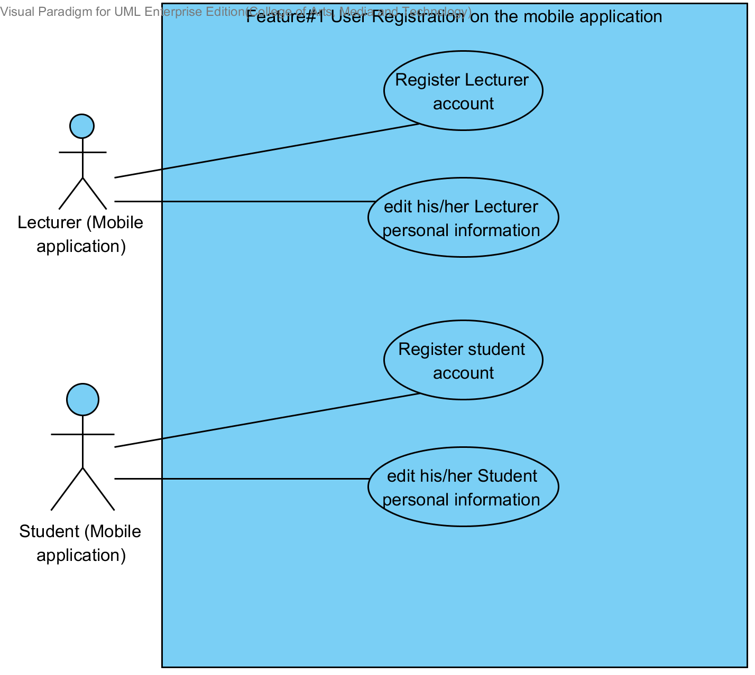

**Description**

The functions in this diagram are registration of Lecturer/Student on the mobile application for using the system.

### **3.1.2 Login to the system Use Case Diagram**

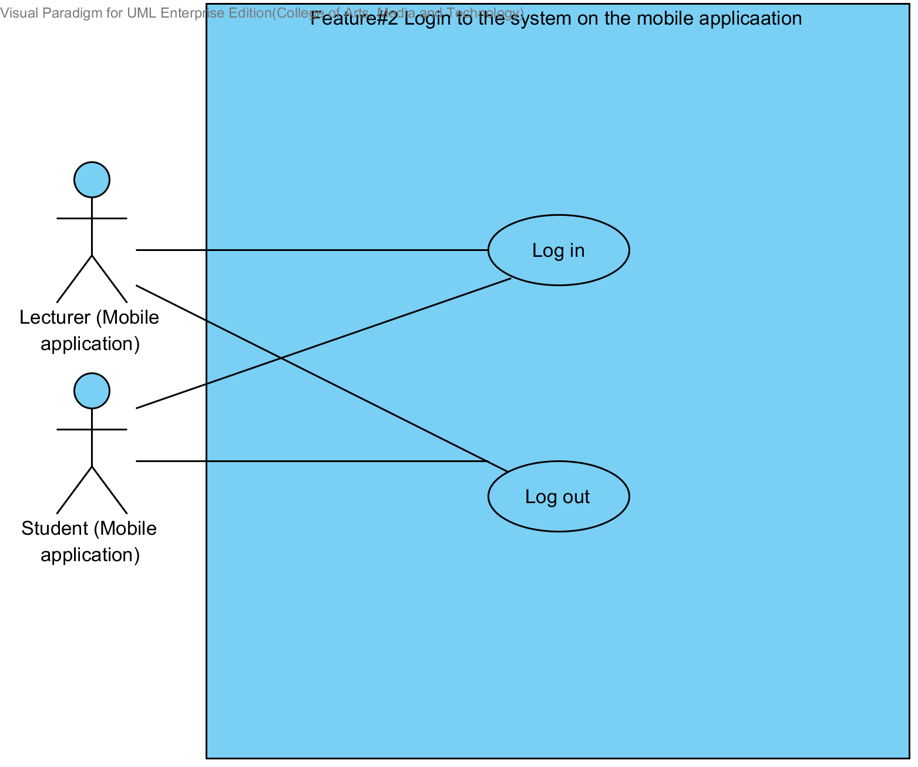

**Description**

The functions in this diagram are accession to the system of Lecturer/Student on the mobile application.

### **3.1.3 Course management Use Case Diagram**

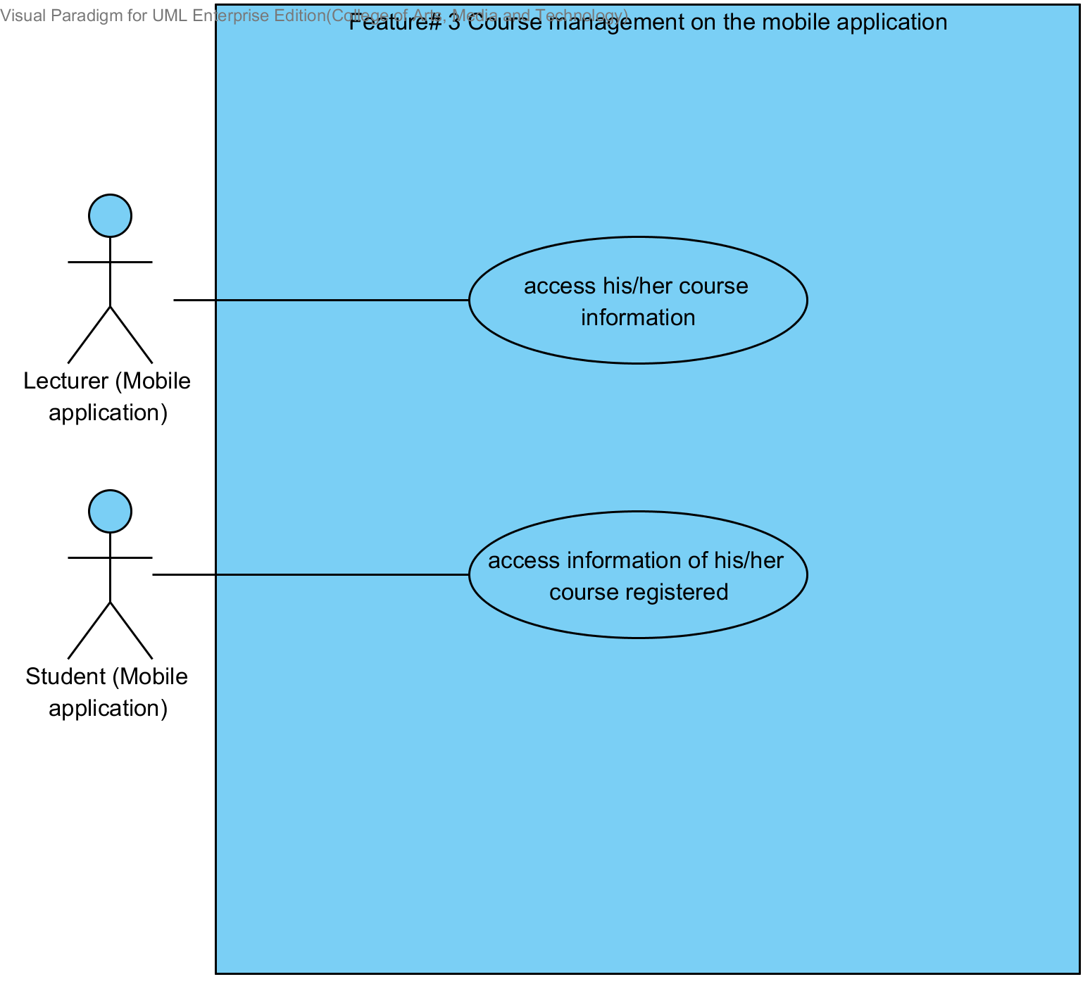

**Description**

The functions in this diagram are accession to courses information that were taught by Lecturer on the mobile application. Student access to courses information that were registered on the mobile application. Users need login before use the system.

### **3.1.4 Assignments and quizzes management Use Case Diagram**

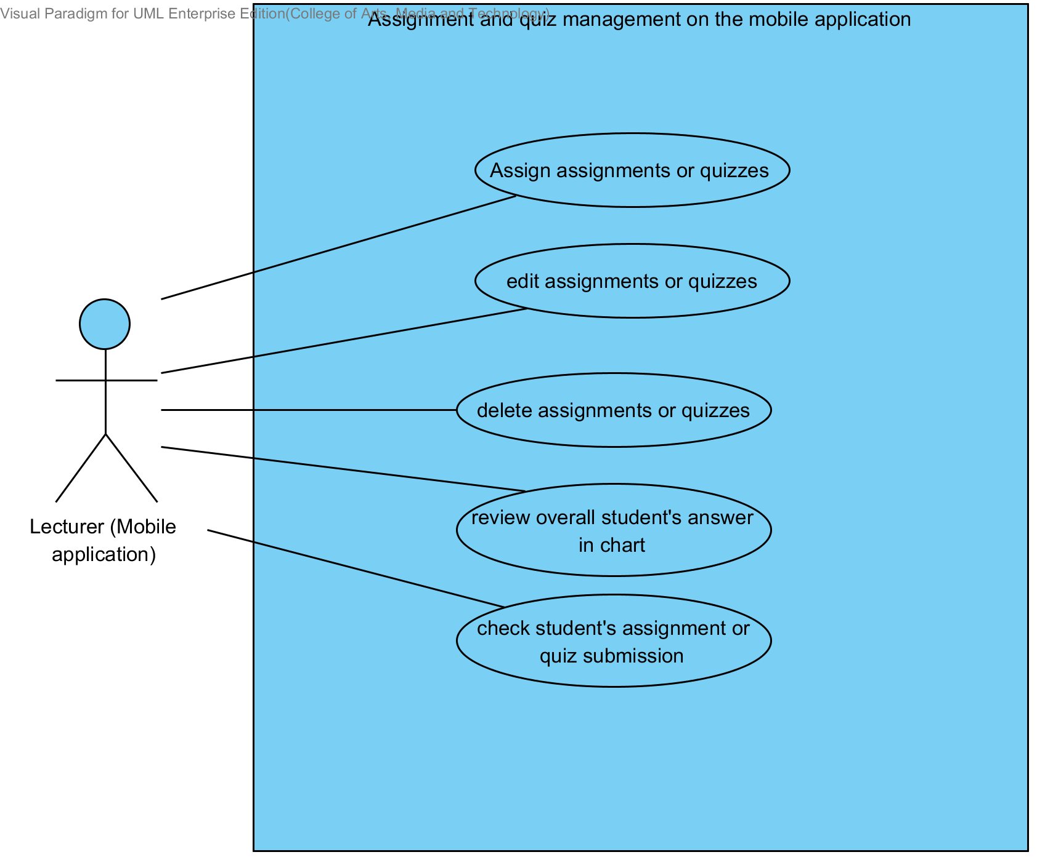

**Description**

The functions in this diagram are assignments and quizzes management by Lecturer on the mobile application. Which provide assignation assignments or quizzes, edition assignments or quizzes, deletion assignments or quizzes, review overall student’s answer in chart, and checking student submission. Lecturer need login before user the system.

### **3.1.5 Taking assignments and quizzes Use Case Diagram**

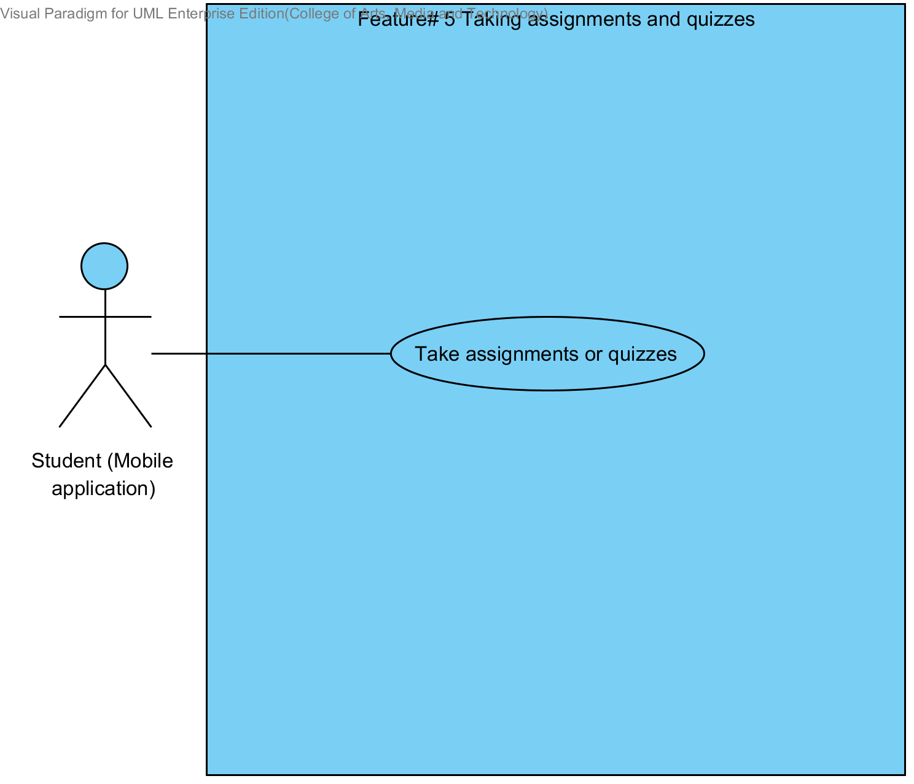

**Description**

The functions in this diagram are taking assignment and quizzes by Student. Student need login before user the system.

# **Chapter Four | Use case description**

## **4.1 Lecturer registers to the system (UC-01)**

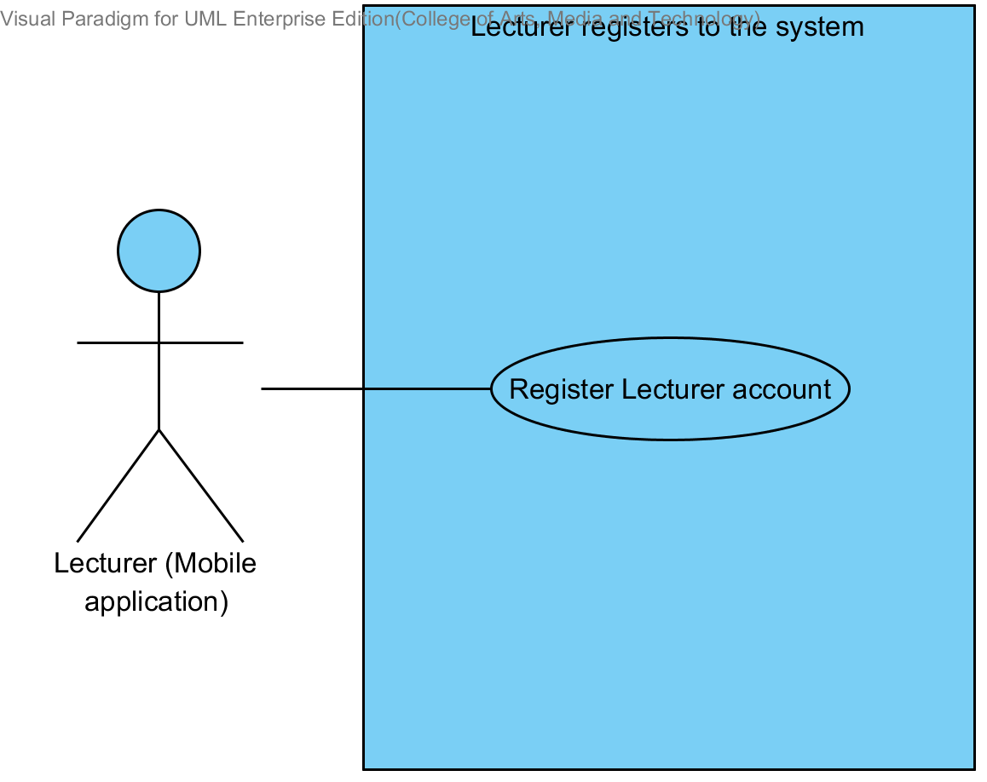

|  |  |  |  |  |
| --- | --- | --- | --- | --- |
| **Use Case ID:** | UC-01 | | | |
| **Use Case Name:** | Lecturer registers to the system | | | |
| **Created By:** | Mr.Tanadol Parn-ong | | **Last Updated By:** | Mr.Tanadol Parn-ong |
| **Date Created:** | 10/05/2014 | | **Last Revision Date:** | 10/05/2014 |
| **Actors:** | | Lecturer | | |
| **Description:** | | This use case is provided for Lecturer request to register account to the system on the mobile application. | | |
| **Trigger:** | | Submit the Lecturer registration form | | |
| **Preconditions:** | | N/A | | |
| **Post conditions:** | | Lecturer account waits to approve from Administrator. | | |
| **Normal Flow:** | | 1. Lecturer enters to Lecturer registration page. 2. The system redirects to Lecturer registration page on the mobile application. 3. The system provides Lecturer registration interface on the mobile application, including lecturer ID, lecturer username, lecturer password, lecturer name, lecturer faculty, lecturer department, lecturer email, and lecturer tel. 4. Lecturer provides the Lecturer information into the registration page. 5. Lecturer submits the Lecturer registration form into the mobile application. 6. The system validates the format of the Lecturer personal information. 7. The system validates the duplication of the lecturer username. 8. The system stores the Lecturer personal information into the system. 9. The system displays “Registration Successful” message on the mobile application. 10. The system redirects to Lecturer main page on the mobile application. | | |
| **Alternative Flows:** | | 6A. when the lecturer ID format is wrong. The system provides the error message as followed:  1. The system displays “The Lecturer ID must be the number only” on the mobile application.  2. Use Case resumes on step 4 of normal flow.  6B. when the lecturer username format is wrong. The system provides the error message as followed:  1. The system displays “The Lecturer’s username must be only 4-16 alphabet characters” on the mobile application. 2. Use Case resumes on step 4 of normal flow.  6C. when the lecturer password format is wrong. The system provides the error message as followed:  1. The system displays “The Lecturer’s password must be only 4-16 characters” on the mobile application. 2. Use Case resumes on step 4 of normal flow.  6D. when the lecturer name format is wrong. The system provides the error message as followed:  1. The system displays “The Lecturer’s name must be the combination of alphabet and space only” on the mobile application. 2. Use Case resumes on step 4 of normal flow.  6E. when the lecturer tel format is wrong. The system provides the error message as followed:  1. The system displays “The Lecturer’s tel must be number only” on the mobile application. 2. Use Case resumes on step 4 of normal flow.  6F. when the lecturer email format is wrong. The system provides the error message as followed:  1. The system displays “The Lecturer’s email must be the character and only one @ symbol” on the mobile application. 2. Use Case resumes on step 4 of normal flow.  7A. when the lecturer username is duplicate with exist lecturer username in the system. The system provides the error message as followed: “Existing Lecturer’s username, please using different Lecturer’s username” on the mobile application. | | |
| **Exceptions:** | | N/A | | |
| **Includes:** | | N/A | | |
| **Frequency of Use:** | | Only at the first time when user begins to use this application. | | |
| **Assumptions:** | | N/A | | |
| **Notes and Issues:** | | N/A | | |

**URS2-1. Lecturer can register to the system**

Lecturer must register into the mobile application, in order to using the other features as Lecturer. Lecturer have to provide lecturer ID, lecturer username, lecturer password, lecturer name, lecturer faculty, lecturer department, lecturer email, and lecturer tel into the system. After, the registration has been completed. The mobile application will redirect to the Lecturer main page.

**Actor:** The users

**Prerequisite:** -

***Input:***

|  |  |  |  |
| --- | --- | --- | --- |
| Name | Description | Example | Remarks |
| lecturer ID | Only number is allowed. | 21115011 |  |
| lecturer username | Only Alphabet is allowed, within the range of 4-16 Characters | “tony” |  |
| lecturer password | Can be any character within the range of 4-16 characters. | “12345” |  |
| lecturer name | Only The combination of alphabet and space is allowed. | “Tony Stark” |  |
| lecturer faculty | Can be any character is allowed. | College of Arts media and technology, Chiang mai University |  |
| lecturer department | Can be any character is allowed. | Software engineer |  |
| lecturer email | The combination of character and only one @ symbol is allowed. | tony999@gmail.com |  |
| lecturer tel | Only number is allowed. | 0832109999 |  |

***Flow of Execution:***

1. Lecturer enters to Lecturer registration page.
2. Lecturer provides the Lecturer information into the registration page.
3. Lecturer submit the Lecturer registration form into the mobile application.

**Alternative Flow:**

3A. if Lecturer input data in the wrong format, the system should provide the error message as followed:

* + The wrong lecturer ID format: The error message is “The Lecturer ID must be the number only”
  + The wrong lecturer username format: The error message is “The Lecturer’s username must be only 4-16 alphabet characters”
  + The wrong lecturer password format: The error message is “The Lecturer’s password must be only 4-16 characters”
  + The wrong lecturer name format: The error message is “The Lecturer’s name must be the combination of alphabet and space only”
  + The wrong lecturer tel format: The error message is “The Lecturer’s tel must be number only”
  + The wrong lecturer email format: The error message is “The Lecturer’s email must be the character and only one @ symbol”

3B. if Lecturer submitted the data, but there is the existing username in the system. The system won’t allow the user the register with that Username. The system will display the error message “Existing Lecturer’s username, please using different Lecturer’s username” to the user.

**System Requirement Specification of URS2-1**

**SRS2-1-1:** The system shall redirect to Lecturer registration page on the mobile application.

**SRS2-1-2:** The system shall redirect to Lecture main page on the mobile application.

**SRS2-1-3:** The system shall provide Lecturer registration interface on the mobile application, including lecturer ID, lecturer username, lecturer password, lecturer name, lecturer faculty, lecturer department, lecturer email, and lecturer tel for Lecturer register to the system.

**SRS2-1-4:** The system shall store the Lecturer personal information into the system after Lecturer submitted his/her register information from Lecturer registration interface on the mobile application.

**SRS.2-1-5:** The system shall display “Registration Successful” message when Lecturer registered the Lecturer account in Lecturer registration interface on the mobile application.

**SRS.2-1-6:** The system shall validate the format of the Lecturer personal information after the Lecturer submitted his/her information from Lecturer registration interface on the mobile application.

**SRS.2-1-7:** The system shall display “The Lecturer ID must be the number only” when the lecturer ID format is wrong.

**SRS.2-1-8:** The system shall display “The Lecturer’s username must be only 4-16 alphabet characters” when the lecturer username format is wrong.

**SRS.2-1-9:** The system shall display “The Lecturer’s password must be only 4-16 characters” when the lecturer password format is wrong.

**SRS.2-1-10**: The system shall display “The Lecturer’s name must be the combination of alphabet and space only” when the lecturer name format is wrong.

**SRS.2-1-11:** The system shall display “The Lecturer’s tel must be number only” when the lecturer tel format is wrong.

**SRS.2-1-12:** The system shall validate the duplication of the lecturer username after Lecturer submitted his/her information from Lecturer registration interface on the mobile application.

**SRS.2-1-13:** The system shall display “Existing Lecturer’s username, please using different Lecturer’s username” when the lecturer username duplicates exist lecturer username.

## **4.2 Student registers to the system (UC-02)**

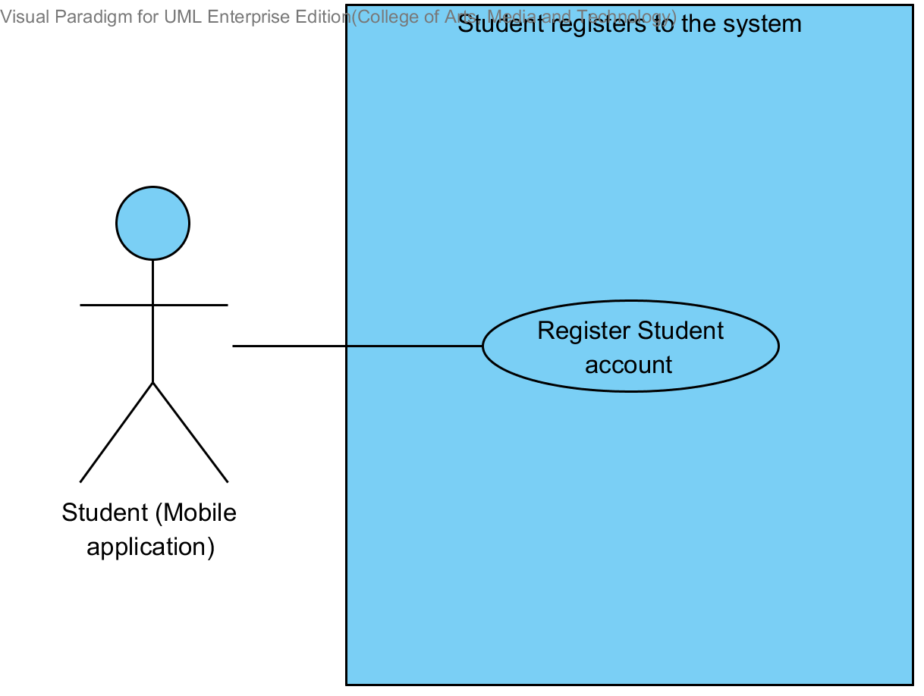

|  |  |  |  |  |
| --- | --- | --- | --- | --- |
| **Use Case ID:** | UC-02 | | | |
| **Use Case Name:** | Student registers to the system | | | |
| **Created By:** | Mr.Tanadol Parn-ong | | **Last Updated By:** | Mr.Tanadol Parn-ong |
| **Date Created:** | 10/05/2014 | | **Last Revision Date:** | 10/05/2014 |
| **Actors:** | | Student | | |
| **Description:** | | This use case is provided for Student request to register account to the system on the mobile application. | | |
| **Trigger:** | | Submit the Student registration form | | |
| **Preconditions:** | | N/A | | |
| **Post conditions:** | | Student account waits to approve from Administrator. | | |
| **Normal Flow:** | | 1. Student enters to Student registration page. 2. The system redirects to Student registration page on the mobile application. 3. The system provides Student registration interface on the mobile application, including student ID, student username, student password, student name, student address, student faculty, student department, student email, and student tel for Student register to the system. 4. Student provides the Student information into the registration page. 5. Student submits the Student registration form into the mobile application. 6. The system validates the format of the Student personal information. 7. The system validates the duplication of the lecturer username. 8. The system stores the Student personal information into the system. 9. The system displays “Registration Successful” message on the mobile application. 10. The system redirects to Student main page on the mobile application. | | |
| **Alternative Flows:** | | 6A. when the student ID format is wrong. The system provides the error message as followed:  1. The system displays “The Student ID must be the number only” on the mobile application.  2. Use Case resumes on step 5 of normal flow.  6B. when the student username format is wrong. The system provide the error message as followed:  1. The system displays “The Student’s username must be only 4-16 alphabet characters” on the mobile application. 2. Use Case resumes on step 4 of normal flow.  6C. when the student password format is wrong. The system provides the error message as followed:  1. The system displays “The Student’s password must be only 4-16 characters” on the mobile application. 2. Use Case resumes on step 4 of normal flow.  6D. when the student name format is wrong. The system provides the error message as followed:  1. The system displays “The Student’s name must be the combination of alphabet and space only” on the mobile application. 2. Use Case resumes on step 4 of normal flow.  6E. when the student tel format is wrong. The system provides the error message as followed:  1. The system displays “The Student’s tel must be number only” on the mobile application. 2. Use Case resumes on step 4 of normal flow.  6F. when the student email format is wrong. The system provides the error message as followed:  1. The system displays “The Student’s email must be the character and only one @ symbol” on the mobile application. 2. Use Case resumes on step 4 of normal flow.  7A. when the student username is duplicate with exist student username in the system. The system provides the error message as followed: “Existing Student’s username, please using different Student’s username” on the mobile application. | | |
| **Exceptions:** | | N/A | | |
| **Includes:** | | N/A | | |
| **Frequency of Use:** | | Only at the first time when user begins to use this application. | | |
| **Assumptions:** | | N/A | | |
| **Notes and Issues:** | | N/A | | |

**URS2-2. Student can register to the system**

Student must register into the mobile application, in order to using the other features as Student. Student have to provide student ID, student username, student password, student name, student address, student faculty, student department, student email, and student tel into the system. After, the registration has been completed. The mobile application will redirect to the Student main page.

**Actor:** The users

**Prerequisite:** -

***Input:***

|  |  |  |  |
| --- | --- | --- | --- |
| Name | Description | Example | Remarks |
| student ID | Only number is allowed. | 542115099 |  |
| student username | Only Alphabet is allowed, within the range of 4-16 Characters | “jenny” |  |
| student password | Can be any character within the range of 4-16 characters. | “12345” |  |
| student name | Only The combination of alphabet and space is allowed. | “Jenny Stark” |  |
| student faculty | Can be any character is allowed. | College of Arts media and technology, Chiang mai University |  |
| student department | Can be any character is allowed. | Software engineer |  |
| student address | Can be any character. | Women dorm 4, Chiang mai university, Chiang mai, Thailand, 50000 |  |
| student email | The combination of character and only one @ symbol is allowed. | jenny999@gmail.com |  |
| student tel | Only number is allowed. | 0823207777 |  |

***Flow of Execution:***

1. Student enters to Student registration page.
2. Student provides the Student information into the registration page.
3. Student submits the Student registration form into the mobile application.

**Alternative Flow**

3A. if Student input data in the wrong format, the system should provide the error message as followed:

* + The wrong student ID format: The error message is “The Student ID must be number only”
  + The wrong username format: The error message is “The Student’s username must be only 4-16 alphabet characters”
  + The wrong password format: The error message is “The Student’s password must be only 4-16 characters”
  + The wrong name format: The error message is “The Student’s name must be the combination of alphabet and space only”
  + The wrong Tel format: The error message is “The Student’s tel must be number only”
  + The wrong student email format: The error message is “The Student’s email must be the character and only one @ symbol”

3B. if Student submitted the data, but there is the existing username in the system. The system won’t allow the user the register with that Username. The system will display the error message “Existing Student’s username, please using different Student’s username” to the user.

**System Requirement Specification of URS2-2**

**SRS2-2-1:** The system shall redirect to Student registration page on the mobile application.

**SRS2-2-2:** The system shall redirect to Student main page on the mobile application.

**SRS2-2-3:**The system shall provide Student registration interface on the mobile application, including student ID, student username, student password, student name, student address, student faculty, student department, student email, and student tel for Student register to the system.

**SRS2-2-4:**The system shall store the Student personal information into the system after Student submitted his/her register information from Student registration interface on the mobile application.

**SRS2-2-5:**The system shall display “Registration Successful” message when Student registered the Student account in Student registration interface on the mobile application.

**SRS2-2-6:**The system shall validate the format of the Student information after the Student submitted his/her information from Student registration interface on the mobile application.

**SRS2-2-7:** The system shall display “The Student ID must be the number only” when the student ID format is wrong.

**SRS2-2-8:**The system shall display “The Student’s username must be only 4-16 alphabet characters” when the student username format is wrong.

**SRS2-2-9:**The system shall display “The Student’s password must be only 4-16 characters” when the student password format is wrong.

**SRS2-2-10:**The system shall display “The Student’s name must be the combination of alphabet and space only” when the student name format is wrong.

**SRS2-2-11:**The system shall display “The Student’s tel must be number only” when the student tel format is wrong.

**SRS2-2-13:**The system shall validate the duplication of the student username after Student submitted his/her information from Student registration interface on the mobile application.

**SRS2-2-14:**The system shall display “Existing Student’s username, please using different Student’s username” when the student username duplicates exist student username.

## **4.3 Lecturer edits personal information (UC-03)**

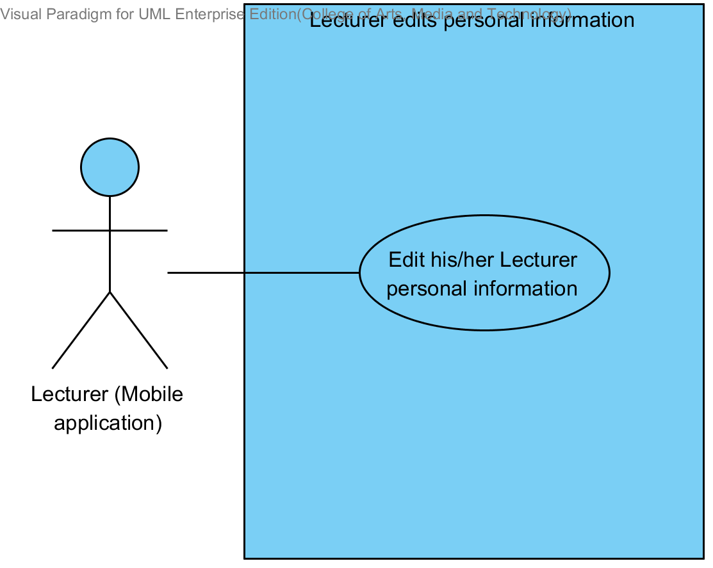

|  |  |  |  |  |
| --- | --- | --- | --- | --- |
| **Use Case ID:** | UC-03 | | | |
| **Use Case Name:** | Lecturer edits personal information. | | | |
| **Created By:** | Mr.Tanadol Parn-ong | | **Last Updated By:** | Mr.Tanadol Parn-ong |
| **Date Created:** | 10/05/2014 | | **Last Revision Date:** | 10/05/2014 |
| **Actors:** | | Lecturer | | |
| **Description:** | | This use case is provided for Lecturer edits his/her personal information on the mobile application. | | |
| **Trigger:** | | Submit edition personal information form | | |
| **Preconditions:** | | Lecturer log in to the system already. | | |
| **Post conditions:** | | Lecturer edits his/her personal information are successful. | | |
| **Normal Flow:** | | 1. Lecturer enters to Lecturer main page. 2. The system redirects to Lecture main page on the mobile application. 3. Lecturer enters to Lecturer personal information page. 4. The system redirects to Lecturer personal information interface on the mobile application. 5. The system provides Lecturer personal information interface on the mobile application, including lecturer password, lecturer name, lecturer faculty, lecturer department, lecturer email, and lecturer tel. 6. Lecturer provides information that want to edit. 7. Lecturer provides confirm password for editing. 8. Lecturer submits edition personal information on the mobile application. 9. The system validates the format of the Lecture personal information. 10. The system validates the similarity of password and confirm password 11. The system updates Lecturer personal information into the system. 12. The system displays “Editing Information Successful” message on the mobile application. | | |
| **Alternative Flows:** | | 9C. when the lecturer password format is wrong. The system provides the error message as followed:  1. The system displays “The Lecturer’s password must be only 4-16 characters” on the mobile application. 2. Use Case resumes on step 5 of normal flow.  9D. when the lecturer name format is wrong. The system provides the error message as followed:  1. The system displays “The Lecturer’s name must be the combination of alphabet and space only” on the mobile application. 2. Use Case resumes on step 6 of normal flow.  9E. when the lecturer tel format is wrong. The system provides the error message as followed:  1. The system displays “The Lecturer’s tel must be number only” on the mobile application. 2. Use Case resumes on step 6 of normal flow.  9F. when the lecturer email format is wrong. The system provides the error message as followed:  1. The system displays “The Lecturer’s email must be the character and only one @ symbol” on the mobile application. 2. Use Case resumes on step 6 of normal flow.  10A. when the lecturer password and confirm password is not matched. The system provides the error message as followed:  1. The system displays “Password and confirm password is not matched” on the mobile application. 2. Use Case resumes on step 6 of normal flow. | | |
| **Exceptions:** | | N/A | | |
| **Includes:** | | N/A | | |
| **Frequency of Use:** | | Often | | |
| **Assumptions:** | | N/A | | |
| **Notes and Issues:** | | N/A | | |

**URS2-3. Lecturer can edit his/her personal information.**

Lecturer can edit his/her personal information into the mobile application which consist lecturer ID, lecturer password, lecturer name, lecturer faculty, lecturer department, lecturer email, and lecturer tel.

**Actor:** Lecturer

**Prerequisite:** Lecturer must have logged**.**

***Input:***

|  |  |  |  |
| --- | --- | --- | --- |
| Name | Description | Example | Remarks |
| lecturer password | Can be any character within the range of 4-16 characters. | “123456” |  |
| lecturer name | Only The combination of alphabet and space is allowed. | “Tony Stark” |  |
| lecturer faculty | Can be any character is allowed. | College of Arts media and technology, Chiang mai University |  |
| lecturer department | Can be any character is allowed. | Software engineering |  |
| lecturer email | The combination of character and only one @ symbol is allowed. | tony999@gmail.com |  |
| lecturer tel | Only number is allowed. | 0832109999 |  |

***Flow of Execution:***

1. Lecturer enters to Lecturer main page.
2. Lecturer enters to Lecturer personal information page.
3. Lecturer provides information that want to edit.
4. Lecturer provides confirm password for editing.
5. Lecturer submits edition personal information on the mobile application.

**Alternative Flow:**

4A. if Lecturer input data in the wrong format, the system should provide the error message as followed:

* + The wrong password format: The error message is “The Lecturer’s password must be only 4-16 characters”
  + The wrong name format: The error message is “The Lecturer’s name must be the combination of alphabet and space only”
  + The wrong Tel format: The error message is “The Lecturer’s tel must be number only”
  + The wrong lecturer email format: The error message is “The Lecturer’s email must be the character and only one @ symbol”

4B. if Lecturer submitted the data, but password and confirm password is not matched. The system will display the error message “Password and confirm password is not matched” to Lecturer.

**System Requirement Specification of URS2-3**

**SRS2-1-2:** The system shall redirect to Lecture main page on the mobile application.

**SRS2-3-1:** The system shall redirect to Lecturer personal information interface on the mobile application.

**SRS2-3-2:** The system shall provide Lecturer personal information interface on the mobile application, including lecturer password, lecturer name, lecturer faculty, lecturer department, lecturer email, and lecturer tel for Lecturer edits his/her personal information into the system.

**SRS2-3-3:** The system shall update Lecturer personal information into the system after Lecturer submits to edit his/her personal information from Lecturer personal information interface on the mobile application.

**SRS2-3-4:** The system shall display “Editing Information Successful” message when Lecturer edited the Lecturer personal information in Lecturer personal information interface on the mobile application.

**SRS2-3-5:** The system shall validate the format of the Lecture personal information after Lecturer submitted his/her personal information from Lecturer personal information interface on the mobile application.

**SRS2-3-6:** The system shall display “The Lecturer’s password must be only 4-16 characters” when the lecturer password format is wrong.

**SRS2-3-7:** The system shall display “The Lecturer’s name must be the combination of alphabet and space only” when the lecturer name format is wrong.

**SRS2-3-8:** The system shall display “The Lecturer’s tel must be number only” when the lecturer tel format is wrong.

**SRS2-3-9:** The system shall display “The Lecturer’s email must be the character and only one @ symbol” when the lecturer email format is wrong.

**SRS2-3-10:** The system shall validate the similarity of password and confirm password after Lecturer submitted his/her personal information from Lecturer personal information interface in the mobile application.

**SRS2-3-11:** The system shall display “Password and confirm password is not matched” when password and confirm password is not matched.

## **4.4 Student edits personal information (UC-04)**

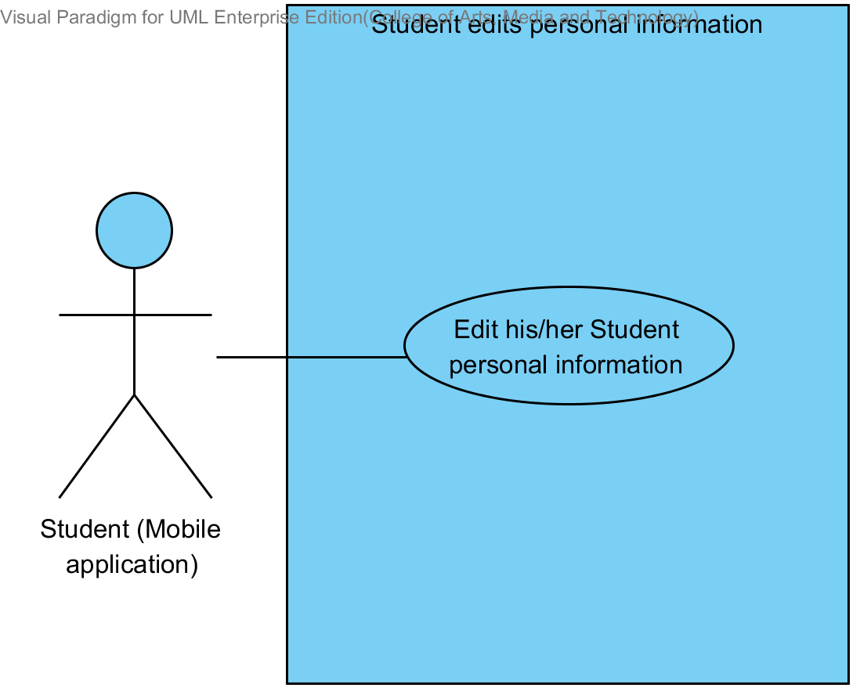

|  |  |  |  |  |
| --- | --- | --- | --- | --- |
| **Use Case ID:** | UC-04 | | | |
| **Use Case Name:** | Student edits personal information. | | | |
| **Created By:** | Mr.Tanadol Parn-ong | | **Last Updated By:** | Mr.Tanadol Parn-ong |
| **Date Created:** | 10/05/2014 | | **Last Revision Date:** | 10/05/2014 |
| **Actors:** | | Student | | |
| **Description:** | | This use case is provided for Student edits his/her personal information on the mobile application. | | |
| **Trigger:** | | Submit edition personal information form | | |
| **Preconditions:** | | Student log in to the system already. | | |
| **Post conditions:** | | Student edits his/her personal information are successful. | | |
| **Normal Flow:** | | 1. Student enters to Student main page. 2. The system redirects to Student main page on the mobile application. 3. Student enters to Student personal information page. 4. The system redirects to Student personal information interface on the mobile application. 5. The system provides Student personal information interface on the mobile application, including student password, student name, student faculty, student department, student address, student email, and student tel. 6. Student provides information that want to edit. 7. Student provides confirm password for editing. 8. Student submits edition personal information on the mobile application. 9. The system validates the format of the Student personal information. 10. The system validates the similarity of password and confirm password 11. The system updates Student personal information into the system. 12. The system displays “Editing Information Successful” message on the mobile application. | | |
| **Alternative Flows:** | | 9C. when the student password format is wrong. The system provides the error message as followed:  1. The system displays “The Student’s password must be only 4-16 characters” on the mobile application. 2. Use Case resumes on step 5 of normal flow.  9D. when the student name format is wrong. The system provides the error message as followed:  1. The system displays “The Student’s name must be the combination of alphabet and space only” on the mobile application. 2. Use Case resumes on step 6 of normal flow.  9E. when the student tel format is wrong. The system provides the error message as followed:  1. The system displays “The Student’s tel must be number only” on the mobile application. 2. Use Case resumes on step 6 of normal flow.  9F. when the student email format is wrong. The system provides the error message as followed:  1. The system displays “The Student’s email must be the character and only one @ symbol” on the mobile application. 2. Use Case resumes on step 6 of normal flow.  10A. when the student password and confirm password is not matched. The system provides the error message as followed:  1. The system displays “Password and confirm password is not matched” on the mobile application. 2. Use Case resumes on step 6 of normal flow. | | |
| **Exceptions:** | | N/A | | |
| **Includes:** | | N/A | | |
| **Frequency of Use:** | | Often | | |
| **Assumptions:** | | N/A | | |
| **Notes and Issues:** | | N/A | | |

**URS2-4. Student can edit his/her personal information.**

Student can edit his/her personal information into the mobile application which consist student ID, student password, student name, student address, student faculty, student department, student email, and student tel.

**Actor:** Student

**Prerequisite:** Student must have logged**.**

***Input:***

|  |  |  |  |
| --- | --- | --- | --- |
| Name | Description | Example | Remarks |
| student ID | Only number is allowed. | 542115099 |  |
| student password | Can be any character within the range of 4-16 characters. | “123456” |  |
| student name | Only The combination of alphabet and space is allowed. | “Jenny Stark” |  |
| student faculty | Can be any character is allowed. | College of Arts media and technology, Chiang mai University |  |
| student department | Can be any character is allowed. | Software engineering |  |
| student address | Can be any character. | Women dorm 4, Chiang mai university, Chiang mai, Thailand, 50000 |  |
| student email | The combination of character and only one @ symbol is allowed. | jenny999@gmail.com |  |
| student tel | Only number is allowed. | 0823207777 |  |

***Flow of Execution:***

1. Student enters to Student main page.
2. Student enters to Student personal information page.
3. Student provides information that want to edit.
4. Student provides confirm password for editing.
5. Student submits edition personal information form.

**Alternative Flow:**

4A. if Student input data in the wrong format, the system should provide the error message as followed:

* + The wrong password format: The error message is “The Student’s password must be only 4-16 characters”
  + The wrong name format: The error message is “The Student’s name must be the combination of alphabet and space only”
  + The wrong Tel format: The error message is “The Student’s tel must be number only”
  + The wrong student email format: The error message is “The Student’s email must be the character and only one @ symbol”

4B. if Student submitted the data, but password and confirm password is not matched. The system will display the error message “Password and confirm password is not matched” to Student.

**System Requirement Specification of URS2-4**

**SRS2-2-2:** The system shall redirect to Student main page on the mobile application.

**SRS2-4-1:** The system shall redirect to Student personal information interface on the mobile application.

**SRS2-4-2:** The system shall provide Student personal information interface on the mobile application, including student password, student name, student faculty, student department, student address, student email, and student tel for Student edits his/her personal information into the system.

**SRS2-4-3:** The system shall update Student personal information into the system after Student submits to edit his/her personal information from Student personal information interface on the mobile application.

**SRS2-4-4:** The system shall display “Editing Information Successful” message when Student edited the Student personal information in Student personal information interface on the mobile application.

**SRS2-4-5:** The system shall validate the format of the Student personal information after Student submitted his/her personal information from Student personal information interface on the mobile application.

**SRS2-4-6:** The system shall display “The Student’s password must be only 4-16 characters” when the student password format is wrong.

**SRS2-4-7:** The system shall display “The Student’s name must be the combination of alphabet and space only” when the student name format is wrong.

**SRS2-4-8:** The system shall display “The Student’s tel must be number only” when the student tel format is wrong.

**SRS2-4-9:** The system shall validate the similarity of password and confirm password after Student submitted his/her personal information from Student personal information interface in the mobile application.

**SRS2-4-10:** The system shall display “Password and confirm password is not matched” when password and confirm password is not matched.

## **4.5 Login to the system (UC-05)**



|  |  |  |  |  |
| --- | --- | --- | --- | --- |
| **Use Case ID:** | UC-05 | | | |
| **Use Case Name:** | Login to the system. | | | |
| **Created By:** | Mr.Tanadol Parn-ong | | **Last Updated By:** | Mr.Tanadol Parn-ong |
| **Date Created:** | 10/05/2014 | | **Last Revision Date:** | 10/05/2014 |
| **Actors:** | | Lecturer, Student | | |
| **Description:** | | This use case is provided for Lecturer/Student log in to the system on the mobile application. | | |
| **Trigger:** | | Submit login form | | |
| **Preconditions:** | | Lecturer/Student registered account already. | | |
| **Post conditions:** | | Lecturer/Student can log in to the system. | | |
| **Normal Flow:** | | 1. Lecturer/Student enters to Login page. 2. The system redirects to Login page on the mobile application. 3. The system providesLogin interface on the mobile application, including username and password 4. Lecturer/Student provides login information into the mobile application. 5. Lecturer/Student submit login form into the mobile application. 6. The system fetches login information of Lecturer/Student from the system to validate the correctness of login information in Login interface on the mobile application. 7. The system redirects to Lecture main page on the mobile application. | | |
| **Alternative Flows:** | | 7A. if Student log in to the system.  1. The system redirects to Student main page on the mobile application.  6C. when the username and password is wrong. The system provides the error message as followed:  1. The system displays “Invalid Username and/or Password” on the mobile application. 2. Use Case resumes on step 4 of normal flow. | | |
| **Exceptions:** | | N/A | | |
| **Includes:** | | N/A | | |
| **Frequency of Use:** | | Often | | |
| **Assumptions:** | | N/A | | |
| **Notes and Issues:** | | N/A | | |

**URS2-5. Lecturer/Student can login to the system.**

After Lecturer/Student account was approved. Lecturer/Student can login to the system by providing username and password into the mobile application.

**Actor:** Lecturer, Student

**Prerequisite:** -

***Input:***

|  |  |  |  |
| --- | --- | --- | --- |
| Name | Description | Example | Remarks |
| lecturer username | Only Alphabet is allowed, within the range of 4-16 Characters | “tony” |  |
| lecturer password | Can be any character within the range of 4-16 characters. | “12345” |  |

***Flow of Execution:***

1. Lecturer/Student enters to Login page.
2. Lecturer/Student provides login information into the mobile application.
3. Lecturer/Student submit login form into the mobile application.

**Alternative Flow**

3A. if the username and password are not matched, the system will display the error message “Invalid Username and/or Password” to the user.

**System Requirement Specification of URS2-5**

**SRS2-1-2:** The system shall redirect to Lecture main page on the mobile application.

**SRS2-2-2:** The system shall redirect to Student main page on the mobile application.

**SRS2-5-1:** The system shall redirect to Login page on the mobile application.

**SRS2-5-2:** The system shall provide Login interface on the mobile application, including username and password for Lecturer/Student login his/her account into the system.

**SRS2-5-3:** The system shall fetch login information of Lecturer/Student from the system to validate the correctness of login information in Login interface on the mobile application.

**SRS2-5-4:** The system shall display “Invalid Username and/or Password” when username and password are wrong to Lecturer/Student.

## **4.6 Logout system (UC-06)**

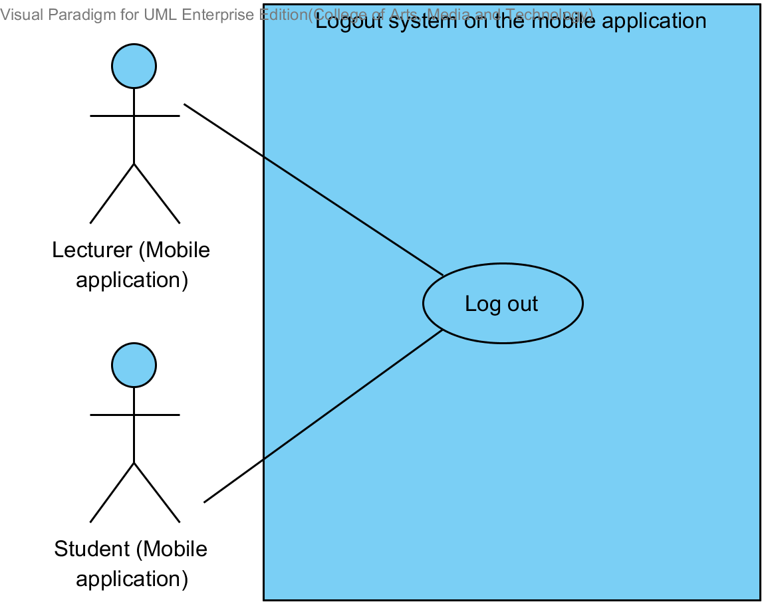

|  |  |  |  |  |
| --- | --- | --- | --- | --- |
| **Use Case ID:** | UC-06 | | | |
| **Use Case Name:** | Logout system. | | | |
| **Created By:** | Mr.Tanadol Parn-ong | | **Last Updated By:** | Mr.Tanadol Parn-ong |
| **Date Created:** | 10/05/2014 | | **Last Revision Date:** | 10/05/2014 |
| **Actors:** | | Lecturer, Student | | |
| **Description:** | | This use case is provided for Lecturer/Student log out the system on the mobile application. | | |
| **Trigger:** | | Submit log out form | | |
| **Preconditions:** | | Lecturer/Student log in to the system already. | | |
| **Post conditions:** | | Lecturer/Student can log in to the system. | | |
| **Normal Flow:** | | 1. Lecturer enters to Lecturer main page. 2. The system redirects to Lecture main page on the mobile application. 3. The system provides Log out form in Lecture main page on the mobile application. 4. Lecturer submits log out form on the mobile application. 5. The system redirects to Login page on the mobile application. | | |
| **Alternative Flows:** | | N/A | | |
| **Exceptions:** | | N/A | | |
| **Includes:** | | N/A | | |
| **Frequency of Use:** | | Often | | |
| **Assumptions:** | | N/A | | |
| **Notes and Issues:** | | N/A | | |

**URS2-6. Lecturer/Student can log out from the system.**

Lecturer/Student can log out from the system on the mobile application.

**Actor:** Lecturer, Student

**Prerequisite:** Lecturer/Student must have logged**.**

***Input: None***

***Flow of Execution:***

1. Lecturer enters to Lecturer main page.
2. Lecturer submits log out form on the mobile application.

**Alternative Flow**

If user is a Student

1A. Student enters to Student main page.

2A. Student submits log out form on the mobile application.

**System Requirement Specification of URS2-6**

**SRS2-1-2:** The system shall redirect to Lecture main page on the mobile application.

**SRS2-2-2:** The system shall redirect to Student main page on the mobile application.

**SRS2-5-1:** The system shall redirect to Login page on the mobile application.

**SRS2-6-1:** The system shall provide Log out form in Lecture main page on the mobile application.

**SRS2-6-2:** The system shall provide Log out form in Student main page on the mobile application.

## **4.7 Lecturer views course information (UC-07)**

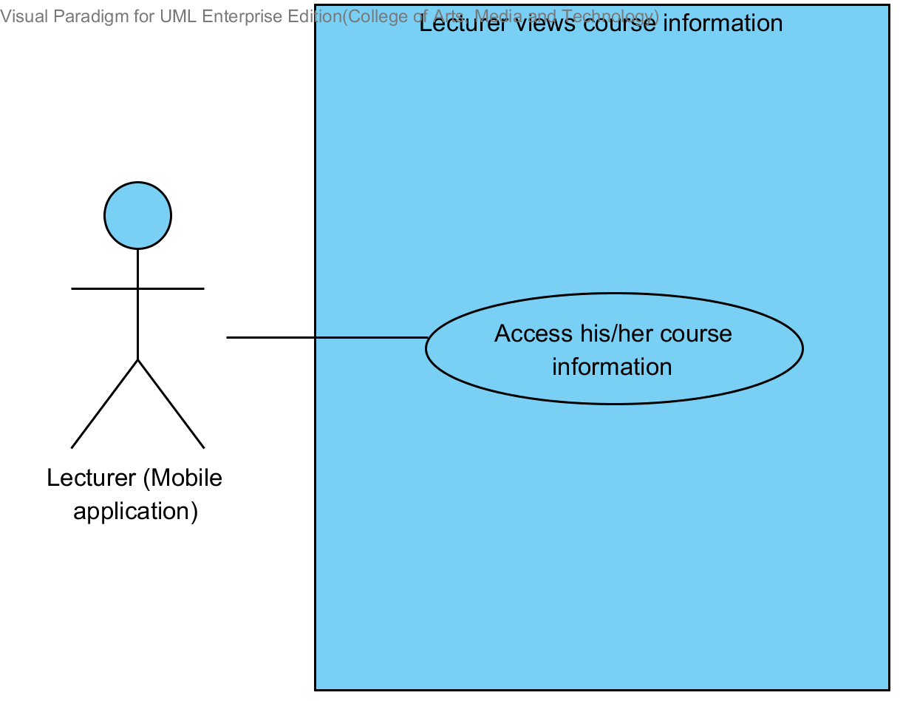

|  |  |  |  |  |
| --- | --- | --- | --- | --- |
| **Use Case ID:** | UC-07 | | | |
| **Use Case Name:** | Lecturer views course information. | | | |
| **Created By:** | Mr.Tanadol Parn-ong | | **Last Updated By:** | Mr.Tanadol Parn-ong |
| **Date Created:** | 10/05/2014 | | **Last Revision Date:** | 10/05/2014 |
| **Actors:** | | Lecturer | | |
| **Description:** | | This use case is provided for Lecturer views his/her course information on the mobile application. | | |
| **Trigger:** | | Submit viewing course information form. | | |
| **Preconditions:** | | Lecturer log in to the system already. | | |
| **Post conditions:** | | Lecturer can view his/her course information. | | |
| **Normal Flow:** | | 1. Lecturer enters to Lecturer main page. 2. The system redirects to Lecture main page on the mobile application. 3. Lecturer enters to Course management page. 4. The system redirects to Course management page on the mobile application. 5. The system provides all courses name in Course management page on the mobile application which were taught by finding from lecturer ID. 6. Lecturer selects a course that want to view. 7. Lecturer submits selecting course form. 8. Lecturer enters to Course main page. 9. The system redirects to Course main page on the mobile application 10. Lecturer submits viewing course information form. 11. The system redirects to Course information page interface on the mobile application, including course name, course credit, course description, lecturer name, a list of students in the course. 12. The system fetches the course information from the system to display into Course information page on the mobile application. | | |
| **Alternative Flows:** | | N/A | | |
| **Exceptions:** | | N/A | | |
| **Includes:** | | N/A | | |
| **Frequency of Use:** | | Often | | |
| **Assumptions:** | | N/A | | |
| **Notes and Issues:** | | N/A | | |

**URS2-7. Lecturer can view courses information.**

Lecturer can view a course information into the mobile application.

**Actor:** Lecturer

**Prerequisite:** Lecturer must have logged**.**

***Input:*** None

***Flow of Execution:***

1. Lecturer enters to Lecturer main page.
2. Lecturer enters to Course management page.
3. Lecturer selects a course that want to view.
4. Lecturer submits selecting course form.
5. Lecturer enters to Course main page.
6. Lecturer submits viewing course information form.

**System Requirement Specification of URS2-7**

**SRS2-1-2:** The system shall redirect to Lecture main page on the mobile application.

**SRS2-7-1:** The system shall redirect to Course management page on the mobile application.

**SRS2-7-2:** The system shall provide all courses name in Course management page on the mobile application which were taught by finding from lecturer ID.

**SRS2-7-3:** The system shall redirect to Course main page on the mobile application.

**SRS2-7-4:** The system shall redirect to Course information page interface on the mobile application, including course name, course credit, course description, lecturer name, a list of students in the course.

**SRS2-7-5:** The system shall fetch the course information from the system to display into Course information page on the mobile application.

## **4.8 Student views course information (UC-08)**

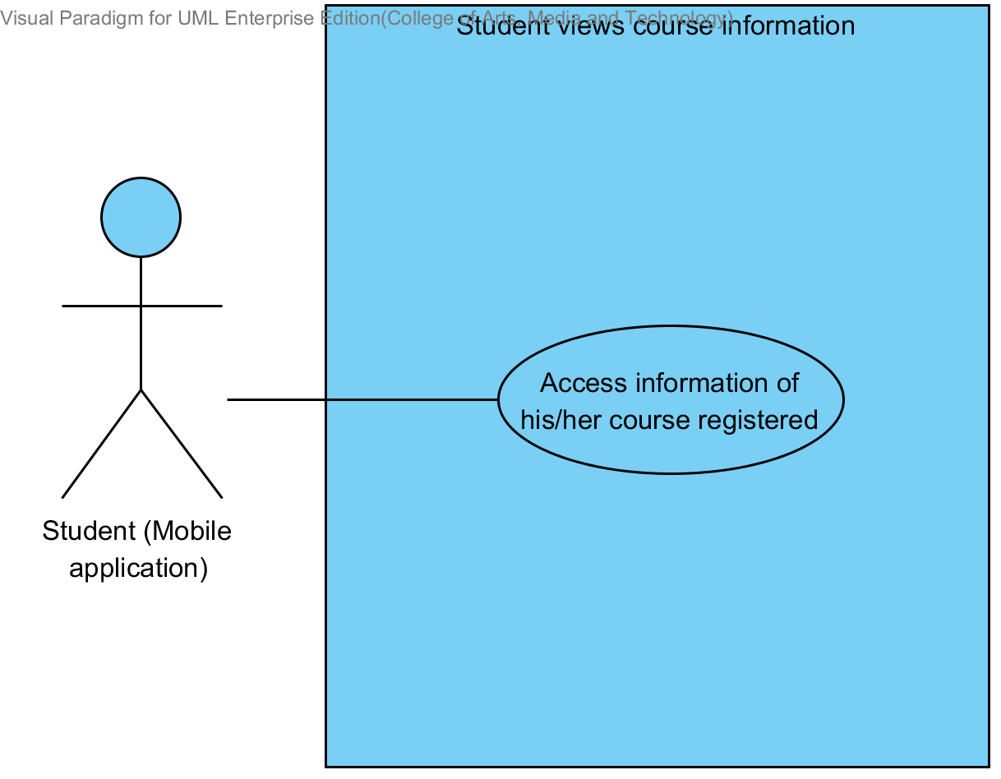

|  |  |  |  |  |
| --- | --- | --- | --- | --- |
| **Use Case ID:** | UC-08 | | | |
| **Use Case Name:** | Student views course information. | | | |
| **Created By:** | Mr.Tanadol Parn-ong | | **Last Updated By:** | Mr.Tanadol Parn-ong |
| **Date Created:** | 10/05/2014 | | **Last Revision Date:** | 10/05/2014 |
| **Actors:** | | Student | | |
| **Description:** | | This use case is provided for Student views his/her course information on the mobile application. | | |
| **Trigger:** | | Submit viewing course information form. | | |
| **Preconditions:** | | Student log in to the system already. | | |
| **Post conditions:** | | Student can view his/her course information. | | |
| **Normal Flow:** | | 1. Student enters to Student main page. 2. The system redirects to Student main page on the mobile application. 3. Student enters to Course management page. 4. The system redirects to Course management page on the mobile application. 5. The system provides all courses name in Course management page on the mobile application which were studied by finding from student ID. 6. Student selects a course that want to view. 7. Student submits selecting course form. 8. Student enters to Course main page. 9. The system redirects to Course main page on the mobile application 10. Student submits viewing course information form. 11. The system redirects to Course information page interface on the mobile application, including course name, course credit, course description, lecturer name, a list of students in the course. 12. The system fetches the course information from the system to display into Course information page on the mobile application. | | |
| **Alternative Flows:** | | N/A | | |
| **Exceptions:** | | N/A | | |
| **Includes:** | | N/A | | |
| **Frequency of Use:** | | Often | | |
| **Assumptions:** | | N/A | | |
| **Notes and Issues:** | | N/A | | |

**URS2-8. Student can view courses information.**

Student can view a course information into the mobile application.

**Actor:** Student

**Prerequisite:** Student must have logged**.**

***Input:*** None

***Flow of Execution:***

1. Student enters to Student main page.
2. Student enters to Overall course page.
3. Student selects a course that want to view.
4. Student submits selecting course form.
5. Student enters to Course main page.
6. Student submits viewing course information form.

**System Requirement Specification of URS2-8**

**SRS2-2-2:** The system shall redirect to Student main page on the mobile application.

**SRS2-7-4:** The system shall redirects to Course information page interface on the mobile application, including course name, course credit, course description, lecturer name, a list of students in the course.

**SRS2-7-5:** The system shall fetch the course information from the system to display into Course information page on the mobile application.

**SRS2-8-1:** The system shall redirect to Overall course page on the mobile application.

**SRS2-8-2:** The system shall provide all courses name in Overall course page on the mobile application which were studied by finding from student ID.

**SRS2-8-3:** The system shall redirects to Course main page on the mobile application.

## **4.9 Lecturer views course information (UC-09)**

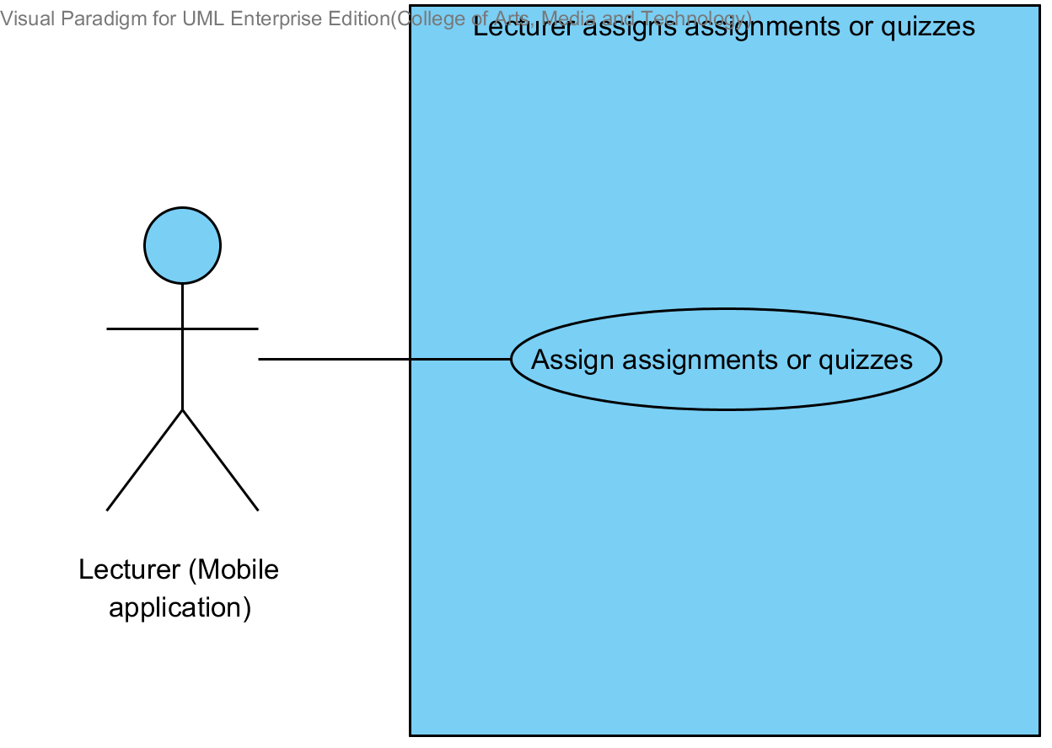

|  |  |  |  |  |
| --- | --- | --- | --- | --- |
| **Use Case ID:** | UC-09 | | | |
| **Use Case Name:** | Lecturer assigns assignments or quizzes. | | | |
| **Created By:** | Mr.Tanadol Parn-ong | | **Last Updated By:** | Mr.Tanadol Parn-ong |
| **Date Created:** | 10/05/2014 | | **Last Revision Date:** | 10/05/2014 |
| **Actors:** | | Lecturer | | |
| **Description:** | | This use case is provided for Lecturer assigns assignments or quizzes on the mobile application. | | |
| **Trigger:** | | Submit creating testing form. | | |
| **Preconditions:** | | Lecturer log in to the system already. | | |
| **Post conditions:** | | Assignments or quizzes were created. | | |
| **Normal Flow:** | | 1. Lecturer enters to Lecturer main page. 2. The system redirects to Lecturer main page on the mobile application. 3. Lecturer enters to Course management page. 4. The system redirects to Course management page on the mobile application. 5. The system provides all courses name in Course management page on the mobile application which were taught by finding from lecturer ID. 6. Lecturer selects a course that want to view. 7. Lecturer submits viewing course form. 8. Lecturer enters to Course main page. 9. The system redirects to Course main page on the mobile application. 10. Lecturer submits overall testing form. 11. Lecturer enters to Overall testing page. 12. The system redirects to Overall testing page on the mobile application. 13. Lecturer submits addition testing form. 14. The system redirects to Addition testing page on the mobile application. 15. The system provides Addition testing page interface on the mobile application, including testing name, a type of testing, an amount of questions, student name, randomize order of the question status, and posting status. 16. Lecturer provides testing information which consist testing name, a type of testing, an amount of questions, student name, randomize order of the question status, and posting status into the Addition testing page. 17. Lecturer submits testing information into mobile application. 18. The system validates testing information from Lecturer. 19. Lecturer enters to Assign assignment and quiz page on the mobile application. 20. The system redirects to Assigning assignment and quiz page on the mobile application. 21. The system provides Assign assignment and quiz page interface on the mobile application, including a type of question, question description, choice description, and an answer for Lecturer assigns assignments or quizzes into the system. 22. Lecturer provides assignment or quiz information which consist a type of question (Multiple choices), question description, choice description, and an answer. 23. Lecturer submits assignment or quiz information into mobile application. 24. The system validates assignment or quiz information from Lecturer. 25. The system redirects to confirm creating testing page. 26. Lecturer submits creating testing form. 27. The system stores the testing information from Lecturer into the system. 28. The system stores assignment or quiz information from Lecturer into the system. 29. The system displays “Creating Assignment Successful” message on the mobile application | | |
| **Alternative Flows:** | | 18A when the amount of questions format is wrong. The system provides the error message as followed:  1. The system displays “Amount of questions must be number only” on the mobile application.  2. Use Case resumes on step 16 of normal flow.  22A if Lecturer provides type of question is true/false question.  1. Lecturer provides question description, choice description, and an answer.  2. Lecturer submits assignment or quiz information into mobile application  3. Use Case resumes on step 24 of normal flow.  22B if Lecturer provides type of question is short answer.  1. Lecturer provides question description.  2. Lecturer submits assignment or quiz information into mobile application  3. Use Case resumes on step 24 of normal flow.  24A when the multiple choices answer format is wrong. The system provides the error message as followed:  1. The system displays “Answer must be a, b, c, and d only” on the mobile application.  2. Use Case resumes on step 22 of normal flow.  24B when the true/false answer format is wrong. The system provides the error message as followed:  1. The system displays “Answer must be a and b only” on the mobile application.  2. Use Case resumes on step 22 of normal flow.  29A if Lecturer assigns quizzes, the system provides the error message as followed:  1. The system displays “Creating Quiz Successful” message on the mobile application | | |
| **Exceptions:** | | N/A | | |
| **Includes:** | | N/A | | |
| **Frequency of Use:** | | Often | | |
| **Assumptions:** | | N/A | | |
| **Notes and Issues:** | | N/A | | |

**URS2-9. Lecturer can assign assignments or quizzes which are multiple choices question, true/false question, and short answers.**

Lecturer can assign assignments or quizzes into the mobile application. Lecturer can limit access to the assignment or quiz of authority. Lecturer must provide testing name, type of testing, an amount of questions, type of question, question information, student name, randomize order of the question status, and posting status.

Lecturer must provide question information by separating from type of questions.

* Lecturer can assign multiple choices questions which provide type of question, question description, choice description, and an answer.
* Lecturer can assign true/false questions which provide type of question, questions description, choice description, and an answer.
* Lecturer can assign short answers which provide type of question, questions description.

**Actor:** Lecturer

**Prerequisite:** Lecturer must have logged**.**

***Input:***

|  |  |  |  |
| --- | --- | --- | --- |
| Name | Description | Example | Remarks |
| testing name | Can be any character only. | Math testing |  |
| type of testing | The system provides two types of testing which are assignment and quiz. Lecturer must select one type only. | Assignment |  |
| amount of question | Only number is allowed. | 3 |  |
| student name | Lecturer adds a list of students for limiting access to the assignment or quiz. | 542115099, 542115091 |  |
| randomize order of the question status | This status is showing status of random order of the question to student. | random |  |
| Posting status | Status is an available and not available. | available |  |

Multiple choices question

|  |  |  |  |
| --- | --- | --- | --- |
| Name | Description | Example | Remarks |
| type of question | The system provides three types of question which are multiple choices, true/false question, and short answer. Lecturer must select one type only. | Multiple choices |  |
| question description | Can be any character is allowed. | What is an answer of 1+1? |  |
| choice description | Choices must have four choices. Can be any character is allowed. | a. 2 b. 1 c. 3 d. 5 |  |
| answer | Only “a, b, c, d” is allowed. | a |  |

True/false question

|  |  |  |  |
| --- | --- | --- | --- |
| Name | Description | Example | Remarks |
| type of question | The system provides three types of question which are multiple choices, true/false question, and short answer. Lecturer must select one type only. | True/false question |  |
| question description | Can be any character is allowed. | Answer of 1+1 is 2. |  |
| choice description | Choices must have two choices. Can be true and false is allowed. | a. false  b. true |  |
| answer | Only “a, b, c, d” is allowed. | b |  |

Short answer

|  |  |  |  |
| --- | --- | --- | --- |
| Name | Description | Example | Remarks |
| type of question | The system provides three types of question which are multiple choices, true/false question, and short answer. Lecturer must select one type only. | Short answer |  |
| question description | Can be any character is allowed. | What is an answer of 1+1? You must explain how to find the answer. |  |

***Flow of Execution:***

1. Lecturer enters to Lecturer main page.
2. Lecturer enters to Course management page.
3. Lecturer selects a course that want to view.
4. Lecturer submits viewing course form.
5. Lecturer enters to Course main page.
6. Lecturer submits overall testing form.
7. Lecturer enters to Overall testing page.
8. Lecturer submits addition testing form.
9. Lecturer provides testing information which consist testing name, a type of testing, an amount of questions, student name, randomize order of the question status, and posting status into the Addition testing page.
10. Lecturer submits testing information into mobile application.
11. Lecturer enters to Assign assignment and quiz page on the mobile application.
12. Lecturer provides assignment or quiz information which consist a type of question (Multiple choices), question description, choice description, and an answer.
13. Lecturer submits assignment or quiz information into mobile application.
14. Lecturer enters to confirm creating testing page.
15. Lecturer submits creating testing form.

**Alternative Flow:**

10A. if Lecturer input data in the wrong format, the system should provide the error message as followed:

* + The wrong amount of questions format: The error message is “Amount of questions must be number only”

12A. Lecturer provides type of question is true/false question.

1. Lecturer provides question description, choice description, and an answer.
2. Lecturer submits assignment or quiz information into mobile application.
3. Flow of execution resumes to step 13.

12B. Lecturer provides type of question is short answer.

1. Lecturer provides question description.
2. Lecturer submits assignment or quiz information into mobile application.
3. The system validates testing information from Lecturer.
4. Flow of execution resumes to step 13.

13A if Lecturer input data in the wrong format in multiple choices answer the system should provide the error message as followed:

* + The wrong answer format: The error message is “Answer must be a, b, c, and d only”

13B if Lecturer input data in the wrong format in true/false answer the system should provide the error message as followed:

* + The wrong answer format: The error message is “Answer must be a and b only”

14A if Lecturer creates a quiz is completed, the system should provide the Successful massage as followed:

* + The system display “Creating Quiz Successful” message.

15B if Lecturer creates an assignment is completed, the system should provide the Successful massage as followed:

* + The system display “Creating Assignment Successful” message.

**System Requirement Specification of URS2-9**

**SRS2-1-2:** The system shall redirect to Lecture main page on the mobile application.

**SRS2-7-1:** The system shall redirect to Course management page on the mobile application.

**SRS2-7-2:** The system shall provide all courses name in Course management page on the mobile application which were taught by finding from lecturer ID.

**SRS2-7-3:** The system shall redirect to Course main page on the mobile application.

**SRS2-9-1:** The system shall redirect to Overall testing page on the mobile application.

**SRS2-9-2:** The system shall redirect to Addition testing page on the mobile application.

**SRS2-9-3:** The system shall provide Addition testing page interface on the mobile application, including testing name, a type of testing, an amount of questions, student name, randomize order of the question status, and posting status for Lecturer adds an assignment or quiz into the system.

**SRS2-9-4:** The system shall validate testing information from Lecturer.

**SRS2-9-5:** The system shall redirect to Assigning assignment and quiz page on the mobile application.

**SRS2-9-6:** The system shall provide Assign assignment and quiz page interface on the mobile application, including a type of question, question description, choice description, and an answer for Lecturer assigns assignments or quizzes into the system.

**SRS2-9-7:** The system shall validate assignment or quiz information from Lecturer.

**SRS2-9-8:** The system shall store the testing information from Lecturer into the system.

**SRS2-9-9:** The system shall store assignment or quiz information from Lecturer into the system.

**SRS2-9-10:** The system shall display “Amount of questions must be number only” message when the amount of questions format is wrong.

**SRS2-9-11:** The system shall display “Answer must be a, b, c, and d only” message when the multiple choices answer format is wrong.

**SRS2-9-12:** The system shall display “Answer must be a and b only” message when the true/false answer format is wrong.

**SRS2-9-13:** The system shall display “Creating Assignment Successful” message when Lecturer assign an assignment is successful.

**SRS2-9-14:** The system shall display “Creating Quiz Successful” message when Lecturer assign a quiz is successful.

**SRS2-9-15:** The system shall redirect to confirm creating testing page.

## **4.10 Lecturer edits course information (UC-10)**

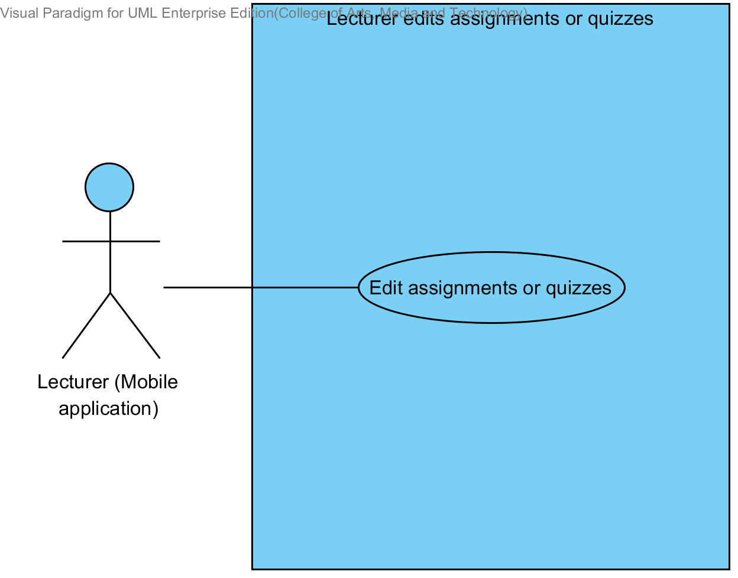

|  |  |  |  |  |
| --- | --- | --- | --- | --- |
| **Use Case ID:** | UC-10 | | | |
| **Use Case Name:** | Lecturer edits assignments or quizzes. | | | |
| **Created By:** | Mr.Tanadol Parn-ong | | **Last Updated By:** | Mr.Tanadol Parn-ong |
| **Date Created:** | 10/05/2014 | | **Last Revision Date:** | 10/05/2014 |
| **Actors:** | | Lecturer | | |
| **Description:** | | This use case is provided for Lecturer edits assignments or quizzes on the mobile application. | | |
| **Trigger:** | | Submit editing testing form. | | |
| **Preconditions:** | | Lecturer log in to the system already. | | |
| **Post conditions:** | | Assignments or quizzes are edited. | | |
| **Normal Flow:** | | 1. Lecturer enters to Lecturer main page. 2. The system redirects to Lecturer main page on the mobile application. 3. Lecturer enters to Course management page. 4. The system redirects to Course management page on the mobile application. 5. The system provides all courses name in Course management page on the mobile application which were taught by finding from lecturer ID. 6. Lecturer selects a course that want to view. 7. Lecturer submits viewing course form. 8. Lecturer enters to Course main page. 9. The system redirects to Course main page on the mobile application. 10. Lecturer submits overall testing form. 11. Lecturer enters to Overall testing page. 12. The system redirects to Overall testing page on the mobile application. 13. Lecturer select a testing that want to edit. 14. Lecturer submits edition testing form. 15. The system redirects to Edition testing page on the mobile application. 16. The system provides Edition testing page interface on the mobile application, including testing name, a type of testing, an amount of questions, student name, randomize order of the question status, and posting status. 17. The system fetches the testing information from the system to display on Edition testing page on the mobile application. 18. Lecturer provides testing name, type of testing, an amount of questions, student name, randomize order of the question status, and posting status into the testing page. 19. Lecturer submits testing information into mobile application. 20. The system validates testing information from Lecturer. 21. Lecturer enters to Edition assignment and quiz page on the mobile application. 22. The system redirects to Edition assignment and quiz page on the mobile application. 23. The system fetches the assignment or quiz information from the system to display on Edition assignment and quiz page on the mobile application. 24. Lecturer provides type of question (Multiple choices), question description, choice description, and an answer. 25. Lecturer submits assignment or quiz information into mobile application. 26. The system validates assignment or quiz information from Lecturer. 27. The system redirects to confirm edition testing page. 28. Lecturer submits editing testing form. 29. The system updates the testing information from Lecturer into the system. 30. The system updates assignment or quiz information from Lecturer into the system. 31. The system displays “Editing Assignment Successful” message on the mobile application. | | |
| **Alternative Flows:** | | 20A when the amount of questions format is wrong. The system provides the error message as followed:  1. The system displays “Amount of questions must be number only” on the mobile application.  2. Use Case resumes on step 18 of normal flow.  24A if Lecturer provides type of question is true/false question.  1. Lecturer provides question description, choice description, and an answer.  2. Lecturer submits assignment or quiz information into mobile application  3. Use Case resumes on step 26 of normal flow.  24B if Lecturer provides type of question is short answer.  1. Lecturer provides question description.  2. Lecturer submits assignment or quiz information into mobile application  3. Use Case resumes on step 26 of normal flow.  26A when the multiple choices answer format is wrong. The system provides the error message as followed:  1. The system displays “Answer must be a, b, c, and d only” on the mobile application.  2. Use Case resumes on step 24 of normal flow.  26B when the true/false answer format is wrong. The system provides the error message as followed:  1. The system displays “Answer must be a and b only” on the mobile application.  2. Use Case resumes on step 24 of normal flow.  31A if Lecturer edits quizzes, the system provides the error message as followed:  1. The system displays “Editing Quiz Successful” message on the mobile application | | |
| **Exceptions:** | | N/A | | |
| **Includes:** | | N/A | | |
| **Frequency of Use:** | | Often | | |
| **Assumptions:** | | N/A | | |
| **Notes and Issues:** | | N/A | | |

**URS2-10. Lecturer can edit assignments or quizzes information which are multiple choices question, true/false question, and short answers.**

Lecturer can edit assignments or quizzes information into the mobile application. Lecturer can limit access to the assignment or quiz of authority. Lecturer must provide testing name, type of testing, an amount of questions, type of question, question information, student name, randomize order of the question status, and posting status.

Lecturer must provide question information by separating from type of questions.

* Lecturer can edit multiple choices questions which provide type of question, question description, choice description, and an answer.
* Lecturer can edit true/false questions which provide type of question, questions description, choice description, and an answer.
* Lecturer can edit short answers which provide type of question, questions description.

**Actor:** Lecturer

**Prerequisite:** Lecturer must have logged**.**

***Input:***

|  |  |  |  |
| --- | --- | --- | --- |
| Name | Description | Example | Remarks |
| testing name | Can be any character only. | Math testing |  |
| type of testing | The system provides two types of testing which are assignment and quiz. Lecturer must select one type only. | Assignment |  |
| amount of question | Only number is allowed. | 3 |  |
| student name | Lecturer adds a list of students for limiting access to the assignment or quiz. | 542115099, 542115091,  542115092 |  |
| randomize order of the question status | This status is showing status of random order of the question to student. | random |  |
| Posting status | Status is an available and not available. | Available |  |

Multiple choices question

|  |  |  |  |
| --- | --- | --- | --- |
| Name | Description | Example | Remarks |
| type of question | The system provides three types of question which are multiple choices, true/false question, and short answer. Lecturer must select one type only. | Multiple choices |  |
| question description | Can be any character is allowed. | What is an answer of 1+1? |  |
| choice description | Choices must have four choices. Can be any character is allowed. | a. 2 b. 1 c. 3 d. 5 |  |
| answer | Only “a, b, c, d” is allowed. | a |  |

True/false question

|  |  |  |  |
| --- | --- | --- | --- |
| Name | Description | Example | Remarks |
| type of question | The system provides three types of question which are multiple choices, true/false question, and short answer. Lecturer must select one type only. | True/false question |  |
| question description | Can be any character is allowed. | Answer of 1+1 is 2. |  |
| choice description | Choices must have two choices. Can be true and false is allowed. | a. false  b. true |  |
| answer | Only “a, b, c, d” is allowed. | b |  |

Short answer

|  |  |  |  |
| --- | --- | --- | --- |
| Name | Description | Example | Remarks |
| type of question | The system provides three types of question which are multiple choices, true/false question, and short answer. Lecturer must select one type only. | Short answer |  |
| question description | Can be any character is allowed. | What is an answer of 1+1? You must explain how to find the answer. |  |

***Flow of Execution:***

1. Lecturer enters to Lecturer main page.
2. Lecturer enters to Course management page.
3. Lecturer selects a course that want to view.
4. Lecturer submits viewing course form.
5. Lecturer enters to Course main page.
6. Lecturer submits overall testing form.
7. Lecturer enters to Overall testing page.
8. Lecturer selects a testing that want to edit.
9. Lecturer submits edition testing form.
10. Lecturer provides testing name, type of testing, an amount of questions, student name, randomize order of the question status, and posting status into the testing page.
11. Lecturer submits testing information into mobile application.
12. Lecturer enters to Edition assignment and quiz page on the mobile application.
13. Lecturer provides type of question (Multiple choices), question description, choice description, and an answer.
14. Lecturer submits assignment or quiz information into mobile application.
15. Lecturer submits editing testing form.

**Alternative Flow:**

11A. if Lecturer input data in the wrong format, the system should provide the error message as followed:

* + The wrong amount of questions format: The error message is “Amount of questions must be number only”

13A. Lecturer provides type of question is true/false question.

1. Lecturer provides question description, choice description, and an answer.
2. Lecturer submits assignment or quiz information into mobile application.
3. Flow of execution resumes to step 13.

13B. Lecturer provides type of question is short answer.

1. Lecturer provides question description.
2. Lecturer submits assignment or quiz information into mobile application.
3. The system validates testing information from Lecturer.
4. Flow of execution resumes to step 13.

14A if Lecturer input data in the wrong format in multiple choices answer the system should provide the error message as followed:

* + The wrong answer format: The error message is “Answer must be a, b, c, and d only”

14B if Lecturer input data in the wrong format in true/false answer the system should provide the error message as followed:

* + The wrong answer format: The error message is “Answer must be a and b only”

15A if Lecturer edits a quiz is completed, the system should provide the Successful massage as followed:

* + The system display “Editing Quiz Successful” message.

15B if Lecturer edits an assignment is completed, the system should provide the Successful massage as followed:

* + The system display “Editing Assignment Successful” message.

**System Requirement Specification of URS2-10**

**SRS2-1-2:** The system shall redirect to Lecture main page on the mobile application.

**SRS2-7-1:** The system shall redirect to Course management page on the mobile application.

**SRS2-7-2:** The system shall provide all courses name in Course management page on the mobile application which were taught by finding from lecturer ID.

**SRS2-7-3:** The system shall redirect to Course main page on the mobile application.

**SRS2-9-1:** The system shall redirect to Overall testing page on the mobile application.

**SRS2-9-4:** The system shall validate testing information from Lecturer.

**SRS2-9-7:** The system shall validate assignment or quiz information from Lecturer.

**SRS2-9-10:** The system shall display “Amount of questions must be number only” message when the amount of questions format is wrong.

**SRS2-9-11:** The system shall display “Answer must be a, b, c, and d only” message when the multiple choices answer format is wrong.

**SRS2-9-12:** The system shall display “Answer must be a and b only” message when the true/false answer format is wrong.

**SRS2-10-1:** The system shall redirect to Edition testing page on the mobile application.

**SRS2-10-2:** The system shall redirects to Edition assignment and quiz page on the mobile application.

**SRS2-10-3:** The system shall fetch the testing information from the system to display on Edition testing page on the mobile application.

**SRS2-10-4:** The system shall fetch the assignment or quiz information from the system to display on Edition assignment and quiz page on the mobile application.

**SRS2-10-5:** The system shall provide Edition testing page interface on the mobile application, including testing name, a type of testing, an amount of questions, student name, randomize order of the question status, and posting status for Lecturer adds an assignment or quiz into the system.

**SRS2-10-6:** The system shall provide Edition assignment and quiz page interface on the mobile application, including a type of question, question description, choice description, and an answer for Lecturer assigns assignments or quizzes into the system.

**SRS2-10-7:** The system shall update the testing information from Lecturer into the system.

**SRS2-10-8:** The system shall update assignment or quiz information from Lecturer into the system.

**SRS2-10-9:** The system shall display “Editing Assignment Successful” message when Lecturer edits an assignment is successful.

**SRS2-10-10:** The system shall display “Editing Quiz Successful” message when Lecturer edits a quiz is successful.

**SRS2-10-11:** The system shall redirect to confirm edition testing page.

## **4.11 Lecturer deletes course information (UC-11)**

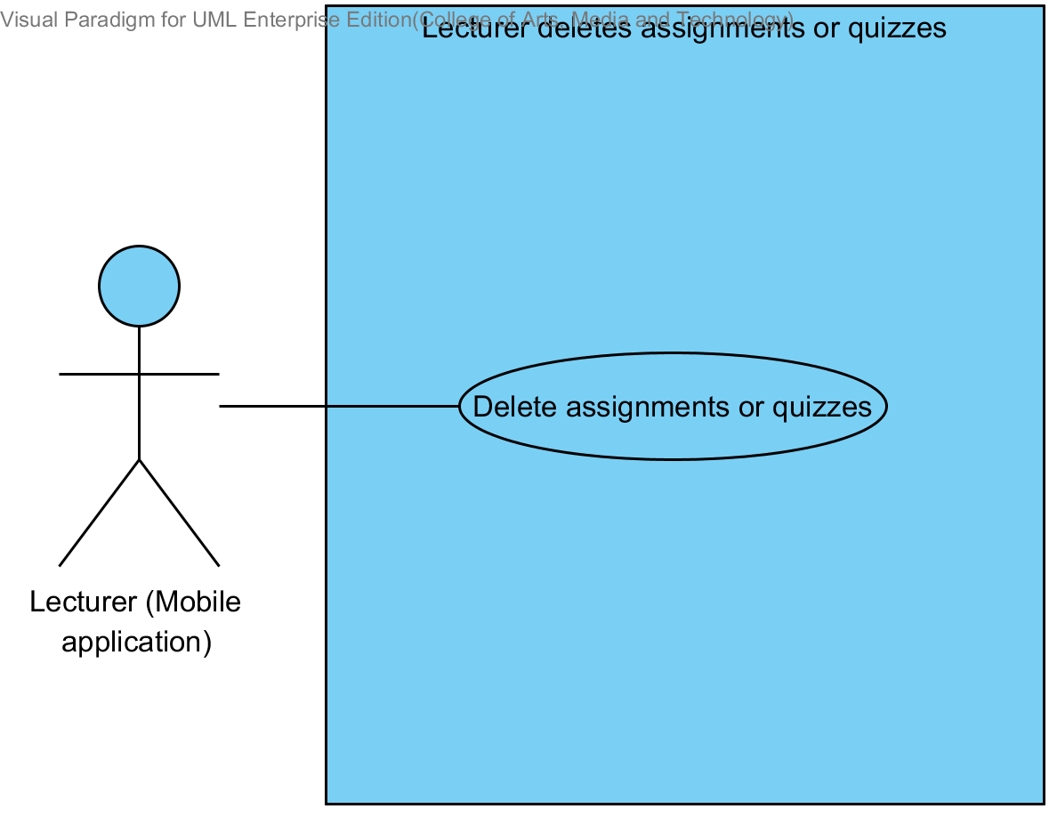

|  |  |  |  |  |
| --- | --- | --- | --- | --- |
| **Use Case ID:** | UC-11 | | | |
| **Use Case Name:** | Lecturer deletes assignments or quizzes. | | | |
| **Created By:** | Mr.Tanadol Parn-ong | | **Last Updated By:** | Mr.Tanadol Parn-ong |
| **Date Created:** | 10/05/2014 | | **Last Revision Date:** | 10/05/2014 |
| **Actors:** | | Lecturer | | |
| **Description:** | | This use case is provided for Lecturer deletes assignments or quizzes on the mobile application. | | |
| **Trigger:** | | Submit deleting testing form. | | |
| **Preconditions:** | | Lecturer log in to the system already. | | |
| **Post conditions:** | | Assignments or quizzes are deleted. | | |
| **Normal Flow:** | | 1. Lecturer enters to Lecturer main page. 2. The system redirects to Lecturer main page on the mobile application. 3. Lecturer enters to Course management page. 4. The system redirects to Course management page on the mobile application. 5. The system provides all courses name in Course management page on the mobile application which were taught by finding from lecturer ID. 6. Lecturer selects a course that want to view. 7. Lecturer submits viewing course form. 8. Lecturer enters to Course main page. 9. The system redirects to Course main page on the mobile application. 10. Lecturer submits overall testing form. 11. Lecturer enters to Overall testing page. 12. The system redirects to Overall testing page on the mobile application. 13. Lecturer select a testing that want to delete. 14. Lecturer submits deleting testing form. 15. The system deletes the testing information from the system. 16. The system deletes assignment or quiz information from the system. 17. The system shall display “Deleting Assignment Successful” message on the mobile application | | |
| **Alternative Flows:** | | 17A if Lecturer deletes a quiz, the system provides the error message as followed:  1. The system displays “Deleting Quiz Successful” message on the mobile application | | |
| **Exceptions:** | | N/A | | |
| **Includes:** | | N/A | | |
| **Frequency of Use:** | | Often | | |
| **Assumptions:** | | N/A | | |
| **Notes and Issues:** | | N/A | | |

**URS2-11. Lecturer can delete assignments or quizzes which are multiple choices question, true/false question, and short answers.**

Lecturer can delete assignments or quizzes into the mobile application.

**Actor:** Lecturer

**Prerequisite:** Lecturer must have logged**.**

***Input:*** None

***Flow of Execution:***

1. Lecturer enters to Lecturer main page.
2. Lecturer enters to Course management page.
3. Lecturer selects a course that want to view.
4. Lecturer submits viewing course form.
5. Lecturer enters to Course main page.
6. Lecturer submits overall testing form.
7. Lecturer enters to Overall testing page.
8. Lecturer select a testing that want to delete.
9. Lecturer submits deleting testing form.

**System Requirement Specification of URS2-11**

**SRS2-1-2:** The system shall redirect to Lecture main page on the mobile application.

**SRS2-7-1:** The system shall redirect to Course management page on the mobile application.

**SRS2-7-2:** The system shall provide all courses name in Course management page on the mobile application which were taught by finding from lecturer ID.

**SRS2-7-3:** The system shall redirects to Course main page on the mobile application.

**SRS2-9-1:** The system shall redirects to Overall testing page on the mobile application.

**SRS2-11-1:** The system shall delete the testing information from the system.

**SRS2-11-2:** The system shall delete assignment or quiz information from the system.

**SRS2-11-3:** The system shall display “Deleting Assignment Successful” message when Lecturer deletes an assignment is successful.

**SRS2-11-4:** The system shall display “Deleting Quiz Successful” message when Lecturer deletes a quiz is successful.

## **4.12 Lecturer reviews student’s answer in chart (UC-12)**

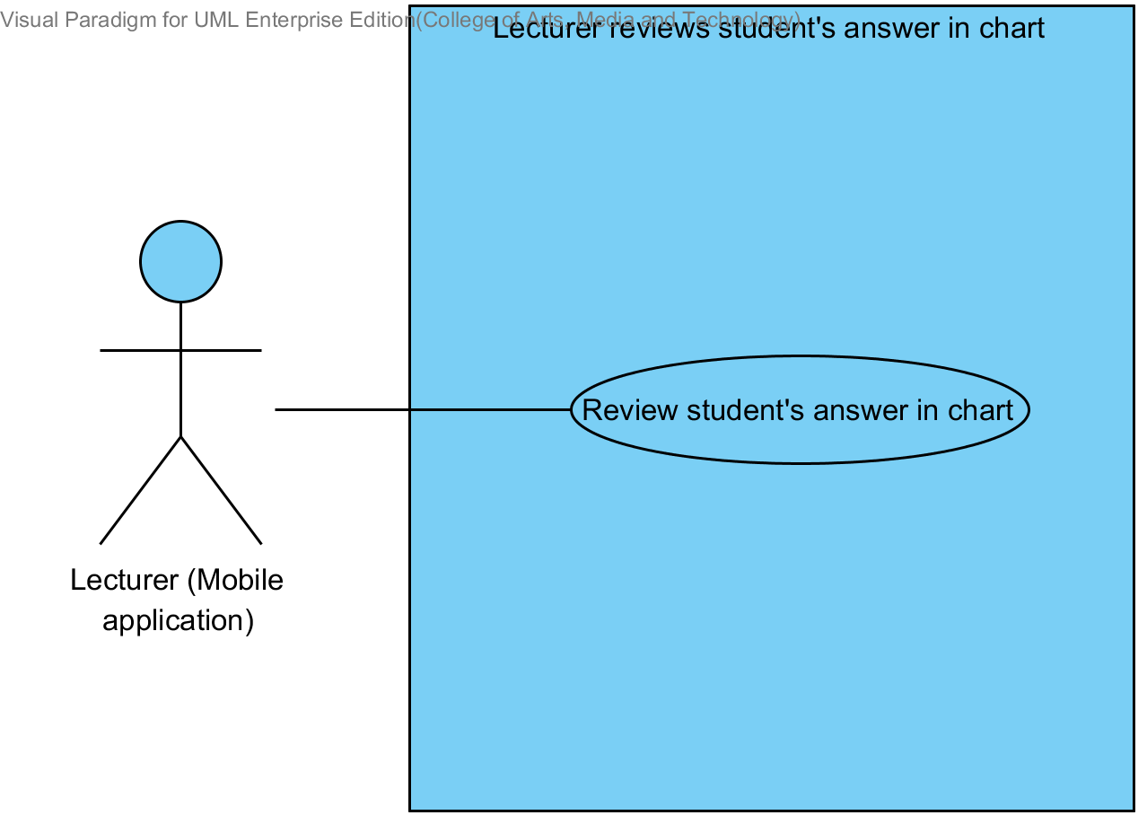

|  |  |  |  |  |
| --- | --- | --- | --- | --- |
| **Use Case ID:** | UC-12 | | | |
| **Use Case Name:** | Lecturer reviews student’s answers in chart | | | |
| **Created By:** | Mr.Tanadol Parn-ong | | **Last Updated By:** | Mr.Tanadol Parn-ong |
| **Date Created:** | 10/05/2014 | | **Last Revision Date:** | 10/05/2014 |
| **Actors:** | | Lecturer | | |
| **Description:** | | This use case is provided for Lecturer reviews student’s answers in chart on the mobile application. | | |
| **Trigger:** | | Submit deleting testing form. | | |
| **Preconditions:** | | Lecturer log in to the system already. | | |
| **Post conditions:** | | Lecturer can review student’s answers in chart | | |
| **Normal Flow:** | | 1. Lecturer enters to Lecturer main page. 2. The system redirects to Lecturer main page on the mobile application. 3. Lecturer enters to Course management page. 4. The system redirects to Course management page on the mobile application. 5. The system provides all courses name in Course management page on the mobile application which were taught by finding from lecturer ID. 6. Lecturer selects a course that want to view. 7. Lecturer submits viewing course form. 8. Lecturer enters to Course main page. 9. The system redirects to Course main page on the mobile application. 10. Lecturer submits overall testing form. 11. Lecturer enters to Overall testing page. 12. The system redirects to Overall testing page on the mobile application. 13. Lecturer select a testing that want to review overall student’s answer in each choice of assignment or quiz in chart format. 14. Lecturer submits chart format of student’s answer form. 15. The system redirects to Chart format of student’s answer page on the mobile application. 16. The system fetches the assignment or quiz information from the system. 17. The system shall display overall student’s answer in each choice of assignment or quiz in chart format into Chart format of student’s answer page on the mobile application. | | |
| **Alternative Flows:** | | N/A | | |
| **Exceptions:** | | N/A | | |
| **Includes:** | | N/A | | |
| **Frequency of Use:** | | Often | | |
| **Assumptions:** | | N/A | | |
| **Notes and Issues:** | | N/A | | |

**URS2-12. Lecturer can review overall student’s answer in each choice of assignment or quiz in chart format.**

Lecturer can review overall student’s answer in each choice of assignment or quiz in chart format into the mobile application. Which Lecturer can analyze thinking of students in decision choose answers.

**Actor:** Lecturer

**Prerequisite:** Lecturer must have logged**.**

***Input:*** None

***Flow of Execution:***

1. Lecturer enters to Lecturer main page.
2. Lecturer enters to Course management page.
3. Lecturer selects a course that want to view.
4. Lecturer submits viewing course form.
5. Lecturer enters to Course main page
6. Lecturer submits overall testing form.
7. Lecturer enters to Overall testing page.
8. Lecturer select a testing that want to review overall student’s answer in each choice of assignment or quiz in chart format.
9. Lecturer submits chart format of student’s answer form.

**System Requirement Specification of URS2-12**

**SRS2-1-2:** The system shall redirect to Lecture main page on the mobile application.

**SRS2-7-1:** The system shall redirect to Course management page on the mobile application.

**SRS2-7-2:** The system shall provide all courses name in Course management page on the mobile application which were taught by finding from lecturer ID.

**SRS2-7-3:** The system shall redirects to Course main page on the mobile application.

**SRS2-9-1:** The system shall redirects to Overall testing page on the mobile application.

**SRS2-12-1:** The system shall redirect to Chart format of student’s answer page on the mobile application.

**SRS2-12-2:** The system shall fetch the assignment or quiz information from the system.

**SRS2-12-3:** The system shall display overall student’s answer in each choice of assignment or quiz in chart format into Chart format of student’s answer page on the mobile application.

## **4.13 Lecturer checks student’s assignment or quiz submission (UC-13)**

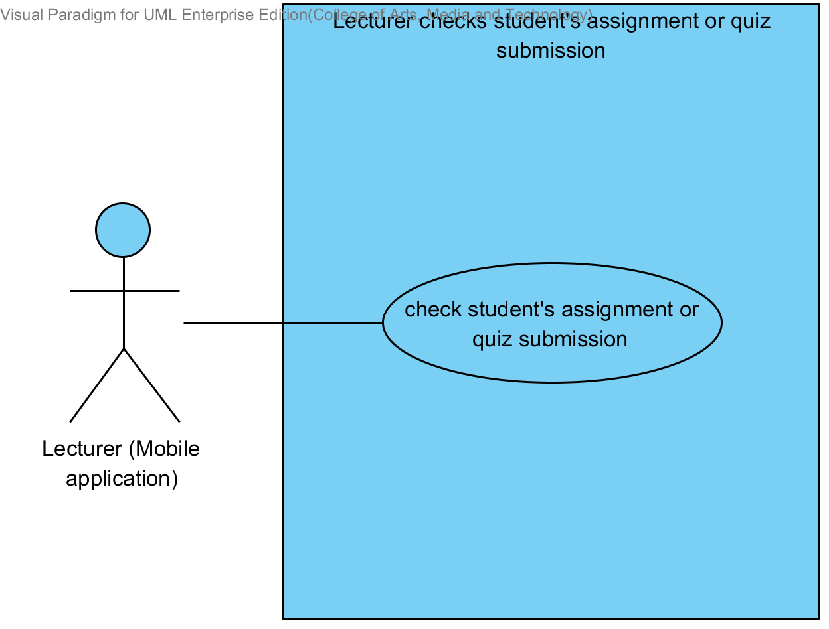

|  |  |  |  |  |
| --- | --- | --- | --- | --- |
| **Use Case ID:** | UC-13 | | | |
| **Use Case Name:** | Lecturer checks student’s assignment or quiz submission. | | | |
| **Created By:** | Mr.Tanadol Parn-ong | | **Last Updated By:** | Mr.Tanadol Parn-ong |
| **Date Created:** | 10/05/2014 | | **Last Revision Date:** | 10/05/2014 |
| **Actors:** | | Lecturer | | |
| **Description:** | | This use case is provided for Lecturer checks student’s assignment or quiz submission on the mobile application. | | |
| **Trigger:** | | Submit deleting testing form. | | |
| **Preconditions:** | | Lecturer log in to the system already. | | |
| **Post conditions:** | | Lecturer can checks student’s assignment or quiz submission. | | |
| **Normal Flow:** | | 1. Lecturer enters to Lecturer main page. 2. The system redirects to Lecturer main page on the mobile application. 3. Lecturer enters to Course management page. 4. The system redirects to Course management page on the mobile application. 5. The system provides all courses name in Course management page on the mobile application which were taught by finding from lecturer ID. 6. Lecturer selects a course that want to view. 7. Lecturer submits viewing course form. 8. Lecturer enters to Course main page. 9. The system redirects to Course main page on the mobile application. 10. Lecturer submits overall testing form. 11. Lecturer enters to Overall testing page. 12. The system redirects to Overall testing page on the mobile application. 13. Lecturer select a testing that want to check students that submit assignments in time. 14. Lecturer submit assignment status form. 15. The system redirects to testing submission page on the mobile application. 16. The system fetches the testing submission information from the system. 17. The system displays testing submission information into testing submission page on the mobile application which consist student name, student ID. | | |
| **Alternative Flows:** | | N/A | | |
| **Exceptions:** | | N/A | | |
| **Includes:** | | N/A | | |
| **Frequency of Use:** | | Often | | |
| **Assumptions:** | | N/A | | |
| **Notes and Issues:** | | N/A | | |

**URS2-13. Lecturer can check whether the assignments are submitted in time.**

Lecturer can check whether who submitted an assignment or quiz in time into the mobile application. Also, who didn’t submit an assignment or quiz in time.

**Actor:** Lecturer

**Prerequisite:** Lecturer must have logged**.**

***Input:*** None

***Flow of Execution:***

1. Lecturer enters to Lecturer main page.
2. Lecturer enters to Course management page.
3. Lecturer selects a course that want to view.
4. Lecturer submits viewing course form.
5. Lecturer enters to Course main page
6. Lecturer submits overall testing form.
7. Lecturer enters to Overall testing page
8. Lecturer select a testing that want to check students that submit assignments in time.
9. Lecturer submit assignment status form.

**System Requirement Specification of URS2-13**

**SRS2-1-2:** The system shall redirect to Lecture main page on the mobile application.

**SRS2-7-1:** The system shall redirect to Course management page on the mobile application.

**SRS2-7-2:** The system shall provide all courses name in Course management page on the mobile application which were taught by finding from lecturer ID.

**SRS2-7-3:** The system shall redirects to Course main page on the mobile application.

**SRS2-9-1:** The system shall redirects to Overall testing page on the mobile application.

**SRS2-13-1:** The system shall redirect to testing submission page on the mobile application.

**SRS2-13-2:** The system shall fetch the testing submission information from the system.

**SRS2-13-3:** The system shall display testing submission information into testing submission page on the mobile application which consist student name, student ID.

## **4.14 Student takes assignments or quizzes (UC-14)**

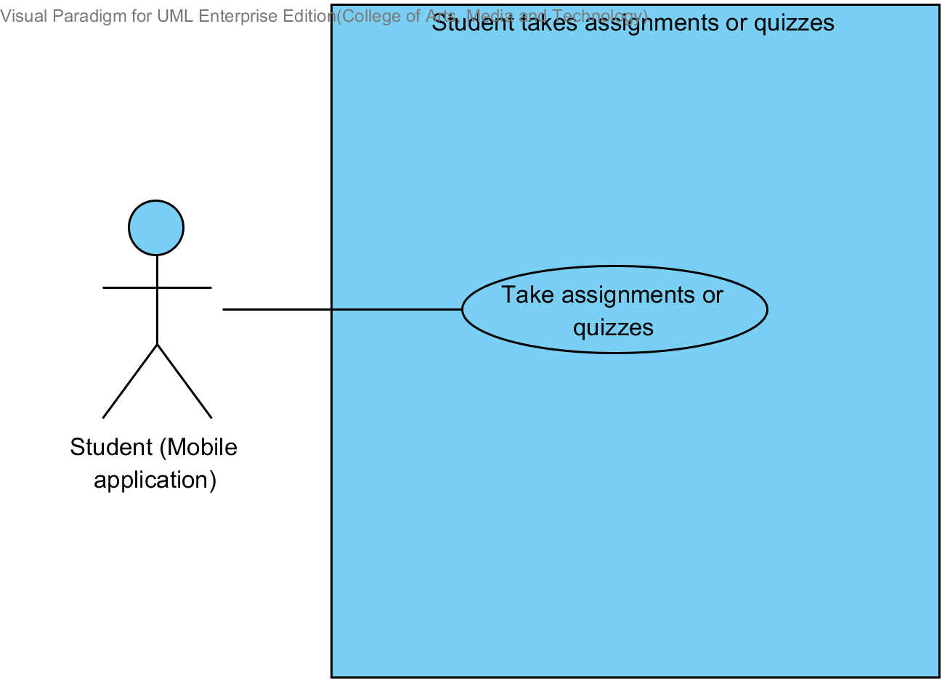

|  |  |  |  |  |
| --- | --- | --- | --- | --- |
| **Use Case ID:** | UC-14 | | | |
| **Use Case Name:** | Student takes assignments or quizzes | | | |
| **Created By:** | Mr.Tanadol Parn-ong | | **Last Updated By:** | Mr.Tanadol Parn-ong |
| **Date Created:** | 10/05/2014 | | **Last Revision Date:** | 10/05/2014 |
| **Actors:** | | Student | | |
| **Description:** | | This use case is provided for Student takes assignments or quizzes on the mobile application. | | |
| **Trigger:** | | Submit deleting testing form. | | |
| **Preconditions:** | | Student log in to the system already. | | |
| **Post conditions:** | | Student can takes assignments or quizzes. | | |
| **Normal Flow:** | | 1. Student enters the Student main page. 2. The system redirects to Student main page on the mobile application. 3. Student enters the Overall course page. 4. The system redirects to Overall course page on the mobile application. 5. The system provides all courses name in Overall course page on the mobile application which were studied by finding from student ID. 6. Student selects a course that want to view. 7. Student submits viewing course form. 8. Student enters to Course main page. 9. The system redirects to Course main page on the mobile application. 10. Student submits overall testing form. 11. Student enters to Overall testing page. 12. The system redirects to Overall testing page on the mobile application. 13. Student select a testing that want to take an assignment or quiz. 14. Student submit taking assignment or quiz form. 15. Student enters to Assignment or quiz page. 16. The system redirects to Assignment or quiz page on the mobile application. 17. The system fetches the assignment or quiz information from the system. 18. The system displays the assignment or quiz information into Assignment or quiz page on the mobile application. 19. Student provides answers in every question. 20. Student submit answers. 21. The system shall store answers of taking an assignment or quiz into the system. | | |
| **Alternative Flows:** | | N/A | | |
| **Exceptions:** | | N/A | | |
| **Includes:** | | N/A | | |
| **Frequency of Use:** | | Often | | |
| **Assumptions:** | | N/A | | |
| **Notes and Issues:** | | N/A | | |

**URS2-14. Student can take assignments or quizzes which are multiple choices, true/false questions, short answers.**

Student can take assignments or quizzes which are multiple choices, true/false questions, short answers by using mobile application.

Student must provide answer information by separating from type of questions.

* Student can take multiple choices questions which provide one answer only in each order of questions.
* Student can take true/false questions which provide one answer only in each order of questions.
* Student can take short answers which provide characters or texts.

**Actor:** Student

**Prerequisite:** Student must have logged**.**

***Input:***

Multiple choices question

|  |  |  |  |
| --- | --- | --- | --- |
| Name | Description | Example | Remarks |
| multiple choices answer | Only “a, b, c, d” is allowed. | a |  |

True/false question

|  |  |  |  |
| --- | --- | --- | --- |
| Name | Description | Example | Remarks |
| true/false answer | Only “a, b, c, d” is allowed. | b |  |

Short answer

|  |  |  |  |
| --- | --- | --- | --- |
| Name | Description | Example | Remarks |
| short answer | Can be any character is allowed. | From the picture is a dog. |  |

***Flow of Execution:***

1. Student enters the Student main page.
2. Student enters the Overall course page.
3. Student selects a course that want to view.
4. Student submits viewing course form.
5. Student enters to Course main page.
6. Student submits overall testing form.
7. Student enters to Overall testing page.
8. Student select a testing that want to take an assignment or quiz.
9. Student submit taking assignment or quiz form.
10. Student enters to Assignment or quiz page.
11. Student provides answers in every question.
12. Student submit answers.

**System Requirement Specification of URS2-14**

**SRS2-2-2:** The system shall redirect to Student main page on the mobile application.

**SRS2-8-1:** The system shall redirect to Overall course page on the mobile application.

**SRS2-8-2:** The system shall provide all courses name in Overall course page on the mobile application which were studied by finding from student ID.

**SRS2-8-3:** The system shall redirect to Course main page on the mobile application.

**SRS2-14-1:** The system shall redirect to Overall testing page on the mobile application.

**SRS2-14-2:** The system shall redirect to Assignment or quiz page on the mobile application.

**SRS2-14-3:** The system shall fetch the assignment or quiz information from the system.

**SRS2-14-4:** The system shall display the assignment or quiz information into Assignment or quiz page on the mobile application.

**SRS2-14-5:** The system shall store answers of taking an assignment or quiz into the system.